**Style Guidelines for Final Year Project ReportsVirtual Fit**

**Final Year Project Report**

**Session 2021-2025**

A project submitted in partial fulfilment of the

The University of Faisalabad Degree

of

Bachelor of Science BSc. (Hons.)in **Computer Science**



Department of Computer Science

The University of Faisalabad, Amin Campus

14 April 2025

Project Details

|  |  |  |  |  |
| --- | --- | --- | --- | --- |
| Type (Nature of project) | | [ ✔ ] **D**evelopment [ ] **R**esearch [ ] **R**&**D** | | |
| Area of specialization | | Website & 3D Modeling | | |
| **Project Group Members** | | | | |
| Sr.# | Reg. # | Student Name | Email ID | *Signature |
| (i) | 2021-BS-CS-150 | Hassan Afzal | hassanafzal2701@gmail.com |  |
| (ii) | 2021-BS-CS-128 | Arham Ahmed | arhamahmed8699@gmail.com |  |
| (iii) | 2022-BS-CS-019 | Ayesha Shakeel | ayeshaasshkeel@gmail.com |  |

*The candidates confirm that the work submitted is their own and appropriate credit has been given where reference has been made to the work of others.

Plagiarism Free Certificate

This is to certify that, I am ________________________ S/D/O _______________________, group leader of FYP under registration no _________________ at the Department of Computer Science, The University of Faisalabad. I declare that my FYP proposal is checked by my supervisor and the similarity index is ________% that is less than 20%, an acceptable limit by HEC. The report is attached herewith as Appendix A.

Name of Group Leader: __________________________ Signature: ________________

Member Name: _________________________________ Signature: ________________

Member Name: _________________________________ Signature: ________________

Name of Supervisor: ____________________ Co-Supervisor (if any): _________________

Designation: __________________________ Designation: _________________________

Signature: ____________________________ Signature: ___________________________

HOD: ________________________________

Signature: ____________________________

Declaration

We here by declare that the content of this project report title “**Virtual Fit**” submitted to the “**DEPARTMENT OF COMPUTER SCIENCE**”, is a documentation of a unique work we created under the supervision of Supervisor “**Rabee Imran**” and that no part has been plagiarized (except the references, some standard mathematical or genetic models/questions/protocols, etc.). Additionally, this project is presented in partial completion of the degree requirements for a Bachelor of Science in “**Computer Science**”. The University may take action if the above statement is found inaccurate at any stage.

|  |  |  |  |  |
| --- | --- | --- | --- | --- |
| **Student Name** | | **Registration No** | | **Signature** |
| Hassan Afzal | | 2021-BS-CS-150 | |  |
| Arham Ahmed | | 2021-BS-CS-128 | |  |
| Ayesha Shakeel | | 2022-BS-CS-019 | |  |
| **Supervisor:** Rabee Imran | | **Signature** | | |
|  | |  | | |

Certificate

We accept the work contained in the report titled **“Virtual Fit”**, written by **“Hassan Afzal, Arham Ahmed, Ayesha Shakeel”** as a confirmation to the required standard for the partial fulfilment of the degree of Bachelor of Science in **Computer Science.**

**Approved by:**

**Supervisor:** Rabee Imran

**Signature: ___________________________________________________________**

**Internal Examiner:**

**Signature: ___________________________________________________________**

**External Examiner:**

**Signature: ___________________________________________________________**

**FYP Coordinator:** Uzair Saeed

**Signature: ___________________________________________________________**

**Head of the Department:** Majid Hussain

**Signature: ___________________________________________________________**

**Date:**

Abstract

The "Virtual Fit" project integrates humanoid models so that buyers can try on clothing, with the goal of improving the current online purchasing model. Nowadays, when purchasing clothing online is prevalent, most customers are afraid to choose well-fitting items because they are unable to put them on. In order to address this problem, our project creates humanoid figure shapes that show customers how the clothing would fit and seem in various sizes and hues.

The primary goal of the Virtual Fit is to efficiently assist clients in trying on clothing that complements their body type in addition to other preferences. One of the primary features of this project is the "choose the best outfit" feature, which allows the user to select a certain style of clothes (top or bottom) and then advises what color combination would be best. This specific function makes sure that consumers can rapidly put together matching outfits, which enhances the satisfaction of their purchasing experience.

According to the project's expected findings, Virtual Fit will significantly improve customer satisfaction by enabling users to connect with the products in an engaging way. By removing uncertainty and offering a more realistic visual picture of the item, Virtual Fit is expected to lower return rates and increase customer trust in online purchases. It is therefore anticipated that this will in turn enhance the entire shopping process hence yielding right decisions with respect to purchases.

In summary, Virtual Try Room represents a significant advancement in e-commerce and is an excellent example of a creative and effective solution to the drawbacks of online shopping for clothing and other necessities.

Table of Contents

CHAPTER 1: INTRODUCTION 1

1.1 Introduction 1

1.2 Aim & Objectives 1

1.3 Problem Statement 2

1.3.1 Extended problem 2

1.3.2 Definition of the Problem 2

1.3.3 Reason for the Issue 3

1.3.4 Relevance and Implications 3

1.3.5 The Crux of Available Solutions 3

1.3.6 Drawback/Gap in Existing Solutions 3

1.3.7 Supporting Data 4

1.4 Proposed System 4

1.5 Project Scope 5

1.6 Assumptions & Constraints 6

1.7 Social Benefits 7

1.8 Business Plan 9

1.8.1 Business Model Canvas 9

1.8.2 Problem 10

1.8.3 Solution 10

1.8.4 Customers 11

1.8.5 Competitors 12

1.8.6 Marketing Plan 13

1.8.7 Revenue 14

1.8.8 SWOT (Strength Weakness Opportunities Threats) Analysis 15

1.8.9 FAB (Features, Attributes, Benefits) Analysis 16

1.9 Report Layout 17

CHAPTER 2: LITERATURE REVIEW/BACKGROUND AND EXISTING WORK 19

2.1 Background 19

2.2 Literature Review 20

2.2.1 Various Subheading 20

2.3 Literature Summary 22

CHAPTER 3: REQUIREMENTS ANALYSIS 23

3.1 Stakeholders List (Actors) 23

3.2 Requirements Elicitation 23

3.2.1 Functional Requirements 24

3.2.2 Non-Functional Requirements 25

3.2.3 Requirements Traceability Matric 27

Explanation of the Matrix: 28

3.3 Use Case Design/Description 29

3.4 Software Development Life Cycle Model 34

3.5 Specific Requirements (Hardware and Software Requirements) 34

3.5.1 Hardware Requirement 34

3.5.2 Software Requirement 36

CHAPTER 4: SOFTWARE DESIGN SPECIFICATION 37

4.1 Design Models 37

4.2 System Architecture 39

4.2.1 Block Diagram 40

4.2.2 Component Diagram 42

4.2.3 Software Architecture Diagram 44

4.3 Data Representation [Diagram + Description] 46

4.3.1 Entity-Relationship Diagram (ERD) 46

4.3.2 UML Class Diagram 48

4.3.3 Data Flow Diagram (DFD) 50

4.3.4 Hierarchical Diagram 52

4.4 Process Flow/Representation 53

4.4.1 Flowchart 53

4.4.2 Sequence Diagram 55

4.4.3 Activity Diagram 58

CHAPTER 5: IMPLEMENTATION 61

5.1 Algorithm 61

5.2 External APIs 64

5.3 User Interface 66

5.3.1 UI Design and Layout 66

5.3.1.1 Main UI Components 66

5.3.2 UI Development Tools and Technologies 66

5.3.3 User Interface Mockups 67

CHAPTER 6: SYSTEM TESTING 79

6.1 Manual Testing 79

6.1.1 System Testing 79

6.1.2 Unit Testing 81

References 90

List of Figures

Figure 1.8.1 Business Model Canvas 9

Figure 3.3 Use Case Diagram 32

Figure 4.2 Work Business Structure 37

Figure 4.3.1 Block Diagram 40

Figure 4.3.2 Component Diagram 42

Figure 4.3.3 Software Architecture Diagram 44

Figure 4.4.1 Entity-Relationship Diagram 46

Figure 4.4.2 UML Class Diagram 48

Figure 4.4.3 Data Flow Diagram 50

Figure 4.4.4 Hierarchical Diagram 51

Figure 4.5.1 Flowchart 53

Figure 4.5.2.1 User Sequence Diagram 55

Figure 4.5.2.2 Admin Sequence Diagram 56

Figure 4.5.3.1 User Activity Diagram 58

Figure 4.5.3.2 Admin Activity Diagram 59

Figure 5.3.3.1 Login Page 67

Figure 5.3.3.2 Signup Page 67

Figure 5.3.3.3 Home Page 68

Figure 5.3.3.4 Shop Page 69

Figure 5.3.3.5 Tee Page 70

Figure 5.3.3.6 Pants Page 71

Figure 5.3.3.7 Contact Us 71

Figure 5.3.3.8 About Us 72

Figure 5.3.3.9 Cart 73

Figure 5.3.3.10 Account 74

Figure 5.3.3.11 Product Description 75

Figure 5.3.3.12 Try-On Room 76

Figure 5.3.3.13 Checkout 77

List of Tables

Table ‎3.1 Software requirements 7

Table 3.1.2 Project Stakeholders for Proposed Project………………………………22

Table 3.2.3 Requirements Tracibility Matrix………...………………………………26

Table 3.5.1 Hardware Requirements…………………………………………………33

Table 3.5.2 Project Stakeholders for Proposed Project………………………………35

Table 6.1.2.1 Test Scenario 1……………………….………………………………...81

Table 6.1.2.2 Test Scenario 2……………………….………………………………...82

Table 6.1.2.3 Test Scenario 3……………………….………………………………...83

Table 6.1.2.4 Test Scenario 4……………………….………………………………...84

Table 6.1.2.5 Test Scenario 5……………………….………………………………...85

Table 6.1.2.6 Test Scenario 6……………………….………………………………...86

Table 6.1.2.7 Test Scenario 7……………………….………………………………...87

Table 6.1.2.8 Test Scenario 8……………………….………………………………...88

Table 6.1.2.9 Test Scenario 9……………………….………………………………...89

List of Abbreviations

All abbreviations in the Project Report should be listed on this page center according to alphabetical order.

**Example:**

|  |  |
| --- | --- |
| AMD | Age related macular degeneration |
| ANN | Artificial neural network |
| CNN | Convolutional neural network |
| DL | Deep learning |
| ML | Machine learning |
| Res-Net | Residual Network |
| U-Net | Universal Network |
| VS | Vessels Segmentation |
|  |  |

# INTRODUCTION

## Introduction

With the increase in online business, the way people go shopping for products has changed and the convenience factor counts. Nevertheless, it still has the major drawback: users cannot wear trial clothes before buying them in the internet shops. Relying solely on the digital images in most cases presents a problem as buyers are in vain about the right size, style and fit they should order. Due to such uncertainty, mall owners experience high return rates and customers’ dissatisfaction with online or virtual shopping.

The “Virtual Fit” project aims to meet this need as it is a more unique concept that lies somewhere between buying clothes in a store and ordering clothes online. It presents a SaaS application that harnesses 3D modeling to design and build general-purpose humanoid models. These avatars help users to estimate how a particular piece of clothing will look on them, and how it will fit.

While existing augmented-reality based systems enhances the real environment, they have their constraints. Virtual Fit is standalone application that can be accessed from modern web browsers so no additional equipment is necessary. Further, it is endowed with an intelligent function of choosing the best outfit, which offers suitable clothing combinations in view of color and styling.

While improving the consumer’s shopping for oneself, this project has many valuable positive externalities for online retailers as it cuts back the return rate, helps build customer trust and therefore grow their satisfaction. Virtual Fit is a logical evolution of the online retail experience in line with current technological developments in 3D modelling and artificial intelligence, one which tackles head-on the problem of virtual try-ons while being realistic to implement.

## Aim & Objectives

**Aim:**  
The main goal of the “Virtual Fit” project is using technology to improve the e-shopping experience by creating a versatile, efficient, and accurate virtual fitting technology. This platform minimizes size, fit and style issues by the utilization of 3D virtual fitting solutions and smart outfit choices.

**Objectives:**

1. **Develop Customizable Humanoid Avatars:**

* Design personalized virtual characters which users can change to match their body size, shape and type.

1. **Implement Realistic Visual Representations:**

* Recreate clothing to show a realistic appearance of the particular piece when worn on an avatar.

1. **Introduce a Color-Matching Outfit Suggestion Feature:**

* Design an AL system that recommends accessories by using the color of the chosen clothes.

1. **Enhance Accessibility and User Experience:**

* Create a graphical user interface that is easy for the end users and that is fully compatible with currently existing web browsers and that will not require the use of any additional devices/features.

1. **Reduce Return Rates for Online Retailers:**

* Reduce uncertainty when making a purchase decision to buy clothes by ensuring that, the size and visual depictions of the garments are very realistic.

1. **Foster Customer Trust and Satisfaction:**

* Return benefits to e-commerce through an appealing and believable virtual try-on service.

All such objectives can be quantified based on system testing and user response along with return rate and are quite realistic for the project.

## Problem Statement

### Extended problem

The “Virtual Fit” project addresses a major issue in the emerging e-commerce industry – one can only try clothes on after purchase. Such limitation results in several problems for consumers and retailers, including more unpredictable decision making, higher rates of return, and lower customer satisfaction.

### Definition of the Problem

At the time of purchasing clothes online, because the customers are unable to touch and feel the clothes, size, fitting and the style of the clothes are other challenges faced by consumers. Thus, while using size charts, pictures and descriptions, potential buyers who have never tried on garments directly cannot be sure about the clothing size which will perfectly suit them and will correspond to their expectations.

### Reason for the Issue

The main cause of this task stems from the problem that is inherent to online stores. Thus, images and descriptions allow for some level of understanding but do not eliminate the risk of how this or that item will look or fit on a customer’s body. They use size charts that do not reflect variation in the body shapes among different people making it difficult for a consumer to select the best product. This lifts a sense of insecurity in the process of shopping.

### Relevance and Implications

The problem of virtual fitting is more prominent because the significance of e-commerce is growing. Statista has issued a report stating that global e-commerce sales will exceed $5 trillion by 2022, and online clothing sales a part of it. Nonetheless, online clothes purchases are quite fragile, which means that the frequency of returns for such products is extremely high for instance, other research shows that return rates for apparels can be as high as 30%, rates that are higher than those of other product types. This not only has consequences on customer satisfaction but it also represents concerns in terms of practicability and cost for the retailers.

### The Crux of Available Solutions

Today’s solutions which include online size charts, virtual fitting rooms, as well as augmented reality tools face the same problem in some way, as they lack accuracy, availability, as well as usability. Some systems are based on simple avatar construction from the measurements that do not give proper depiction of how the clothes are going to fit the person. Moreover, many of them are developed to work with additional equipment (AR glasses or enhanced hardware) which makes solutions not available for all consumers.

### Drawback/Gap in Existing Solutions

While existing systems like virtual fitting rooms from brands such as ModCloth, Gap, and Macy's offer some level of virtual try-on experience, they suffer from several limitations:

* Absence of the fine 3D visualization and individual customization (for example, the ModCloth and Gap).
* Few or no outfit suggestions given chosen garments (e.g., outfit based on clothes from the Gap).
* Other conditions related to additional hardware or complicated configurations (AR systems, for example).

Such disadvantages hamper their efficiency in providing the consumers with the entertaining and credible virtual shopping experience.

### Supporting Data

The same poll carried out by the National Retail Federation in 2021 indicated that approximately three-quarters of customers interviewed said that they would prefer to purchase clothes from a website if they could ‘try’ them on. Additionally, a report completed by Retail Dive showed that consumers’ list of challenges to buying apparel online was headed by the lack of physical trial, at 67%. Such statistics prove the large market need for efficient virtual trials for clothes and accessories.

## Proposed System

The “Virtual Fit” system can help the issue of uncertainties associated with purchasing clothes online through a three-dimensional dressing application. It enables users to personalize their appearance by providing them an opportunity to create body shapes and sizes. The degree afforded by augmented reality let them to ‘wear’ clothes and by analyzing the full range of options that is provided, select garments that would fit perfectly and match their personality.

#### Main Features and Components:

1. **Customizable 3D Avatars:** These avatars can be customized with regard to size and shape of the body to offer good fitting clothing for them.
2. **Realistic Clothing Visualization:** Parametric modeling allows the specification of shapes and colors as well as life-like avatars into which garments and how they fit are modeled.
3. **Color Matching & Outfit Suggestions:** Provides a smart option to select the next outfit based on colors that are selected by the user.
4. **No Additional Hardware Required:** There is no need for AR devices since the platform is deployed on a normal assessable web browser.
5. **User-Friendly Interface:** Clean look and ease to modify and use, for a minimalist appearance which makes products easier to find.

#### Contribution to Solving the Problem:

* **Improved Confidence & Fit:** By doing so, uncertainty about size and style of the outer wear is eliminated and users can predict how it is going to fit or look on them.
* **Reduced Return Rates:** When customers are able to better gauge fit and provide a better picture of style, there will be fewer returns made.
* **Increased Satisfaction:** Getting a well-fitted outfit and recommended clothing provide an exciting shopping experience.
* **Wide Accessibility:** No specialized equipment is required therefore available to anyone, while also easily integrated for retailers.

The creation of “Virtual Fit” makes consumer satisfaction iterative and realistic, thus overcoming the difficulties of purchasing online in terms of fit and style while at the same time cutting operation expenses for retailers.

## Project Scope

The main idea of the “Virtual Fit” project is to create an internet application for the Clothes Brand where users will be able to see how certain types of garments will fit them by trying them on the 3D avatars which will respond to the size and shape variations. The main objective is to make buyer perceived value larger by offering the opportunities to visualize clothes size, how garments fit and the styles, without the physical experience of putting the clothes on.

#### Included in the Project Scope:

* **3D Modeling of Avatars:** Design of clothing that could be adapted to the user’s size, color, and style of clothing by respond; Design and development of human like robots that can be programmed to represent the user’s size, shape, and preferred aesthetic.
* **Clothing Visualization:** The power of rendering accurate clothing colors, textures and the way avatars will fit the garments in 3D perspective.
* **Outfit Suggestions:** A decision support system that suggests accessory color that would best fit with the color of some of the selected clothes.
* **User Interface (UI):** Easy and friendly design of virtual fitting for avatars, measurements upload, and clothes samples.
* **Web Platform:** The system will be reachable through a common platform, which is Web browsers, and thus, the access can be made possible without having to install any new hardware.

#### Not Included in the Project Scope:

* **Augmented Reality (AR):** Some of the assumptions made when developing the project are that: The use of AR-based features and no AR hardware (such as goggles or special devices) will not be incorporated into the project.
* **Real-time Clothing Simulation:** The system does not mimic the dynamics of fabrics or other aspects of clothing; it will strictly create static 3-dimensional garments.
* **Integration with Physical Stores:** This project will not include utilizing a traditional chain linking the system with the physical store, or offering a store experience.

#### Limitations and Restrictions:

* **Hardware Requirements:** What it does is the system is browser based, though some forms of 3D rendered graphics might necessitate, the amount of processing power that the device that the user is employing may not allow.
* **Model Accuracy:** Wrapping will be highly customizable, however, not all avatars may fit in real life due to restrictions in a 3D model and no fabric physics.
* **Initial Learning Curve:** Consumers who have had no prior exposure to 3D modeling, and the virtual try-on system may take a bit of time to get used to the platform.

## Assumptions & Constraints

#### Assumptions:

1. **Internet Access:** The system supposes that users have stable internet connection and device allowing to open and operate modern browser (Chrome, Firefox, Safari etc.)
2. **Basic Digital Literacy:** This means that users should have at least elementary prior experience with using the World Wide Web and purchasing products and services over the Internet.
3. **Standardized Body Measurements:** The system expects users to provide correct dimensions for the avatars as the outcomes will specifically be guided by these dimensions.
4. **Device Compatibility:** The system expects that users will be engaging with the content on a device with enough processing power to render 3D but, the platform should ideally be as lightweight as possible for devices with less processing power.

#### Constraints:

1. **Hardware Limitations:** Even though the system will be web-based, the computations needed for creating such realistic 3D models can strain the hardware resources, thereby denying users with low end, weak devices optimal navigation experience. This could possibly bring inconvenience to the accessibility of some users in that particular platform.
2. **Model Accuracy:** The virtual try-on may be rather realistic yet there are certain drawbacks because it is impossible to reproduce fabric behavior, and creation of accurate 3D models of human body remains difficult to date.
3. **Time and Resources:** The development timeline may extend to years, or if the team is small, or the company has a low budget, the number of features may be reduced or the detail of 3D models and suggested outfits may not be high.
4. **Data Privacy and Security:** The project supposes that a user inputs personal information (for instance, Body Measurements) and therefore the system must obey the legislation norms of data protection to keep such data sensitive safe.

The above assumptions were made after a survey of the current trends in the web-based e-commerce applications and the current technological solutions in 3D rendering techniques. Some of the discovered constraints include hardware limitation and factors concerning model accuracy affirmed through the assessment of existing virtual fitting technologies and the experiences of similar systems.

## Social Benefits

The "Virtual Fit" project offers several positive impacts on society:

* **Improved Accessibility:**  
  The idea is especially beneficial for disabled persons or senior citizens and people living in the rural area who can virtually fit clothes on the internet without physically going to shops.
* **Enhanced Consumer Confidence:**  
  In this case, the system predicts the appearance of the product on the buyer enabling clear decision-making and lesser returns hence increasing customer satisfaction.
* **Reduction in Clothing Waste:**  
  Customers will be able to receive better fitting garments, thus ER2 will have less returned items which in return reduces cost and negative repercussion towards the environment on issues of overproduction and excessive shipping.
* **Support for Sustainable Shopping:**  
  The best outfit selector is a feature that assists the clients in making creative and coherent purchases and discourages irrational ones that are usually careerist in nature.
* **Economic Empowerment for Retailers:**  
  Retailers see less returns from customers and increased interaction with customers, which translate into growth and support of local economy, with minimal and less expensive infrastructure spending by the government.

Overall, Virtual Fit contributes to more inclusive, sustainable, and efficient shopping, benefiting consumers, retailers, and the environment.

## Business Plan

### Business Model Canvas

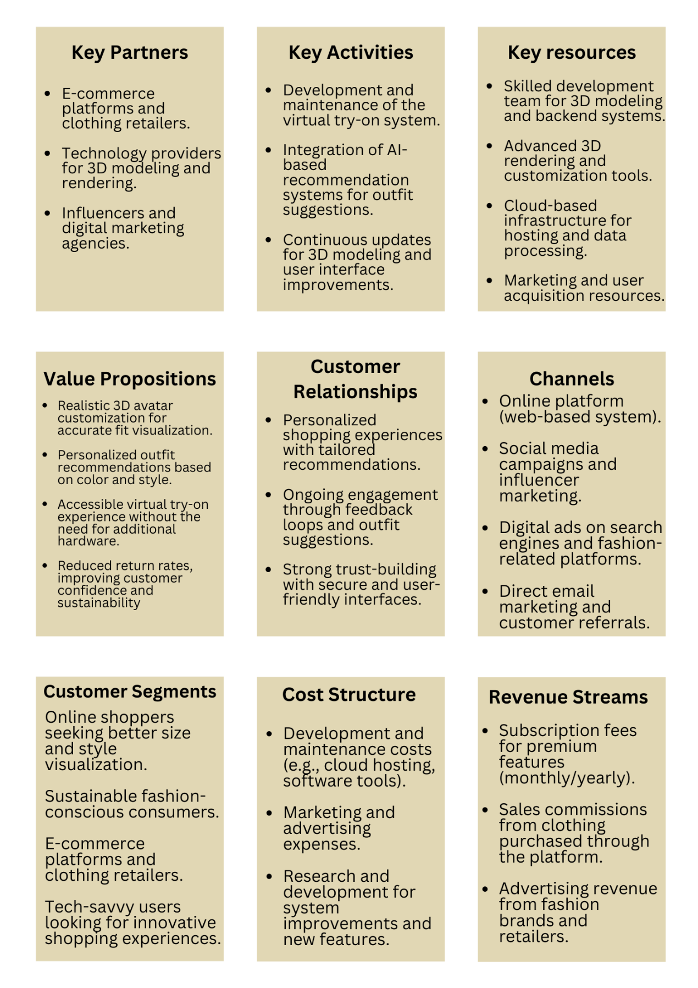 Figure 1.8.1 Business Canvas Model

### Problem

Virtual Fit project targets various possibilities and problems of buyers that can occur during buying clothes online. They all end up into high return rates, level of dissatisfaction and ultimately a rather limited shopping experience.

#### Pain Points the Proposed Solution Aims to Alleviate:

* **Size and Fit Uncertainty:**  
  Customers also have a challenge when trying to pick the correct-sized product because there are differences in size charts and body shapes.
* **High Return Rates:**  
  Misfit and fashion result to irritations and the garments being returned which creates several problems to the retailers including time and cost they incur to deal with the returns.
* **Limited Shopping Experience:**  
  Since clothes can be bought online, the consumer often faces risks and confusion when it comes to buying clothes that suit her.
* **Lack of Personalized Recommendations:**  
  Most websites do not have options for matching outfits or even recommend suitable clothing to wear.
* **Limited Accessibility of Advanced Technologies:**  
  While there are existing virtual try-on solutions, some of these present design complications such as expensive hardware or AR, thus being restricted for most consumers.

The “Virtual Fit” system solves these problems by providing a correct, convenient, and individual virtual fitting, minimizing returns and increasing consumers’ satisfaction.

### Solution

The “Virtual Fit” project contributes to crucial areas of concern in online clothing retail stores by providing an application for an actual- size prediction for clothes with minimal returns.

#### Alignment with the Business Problem:

**Size and Fit Accuracy:**  
The 3D avatars help customers to see accurately how the clothing item will look on them depending on their body type.

**Reduced Return Rates:**  
Realistic virtual try-ons reduce chances of returns for ill fitment or unpreferred styles benefiting the customer.

**Enhanced Shopping Experience:**  
Virtual Fit ensures the online shopping platforms provide an entertaining and accurate experience by simulating the physical store.

**Personalized Recommendations:**  
One of its main functions is to recommend the whole outfits that visually guides the user to make accurate and stylish decisions.

**No Hardware Required:**  
It can be experienced through a browser – no need for installation of special software or equipment.

#### Unique Selling Points:

* Unique fitting 3D avatar for actual fit.
* Simulation of garments how they would look on the body without the need of actually putting them on.
* They are not restricted by any type of hardware enabling across the board compatibility.
* Smart outfits to coincide with each other.
* Scalable, affordable, safe, and ready to implement for retailers.

### Customers

The target customer segments for "Virtual Fit" are:

**Online Shoppers:**

* Characteristics: **Women and young people, aged between 18 and 45, who have a technological inclination and are more likely to shop online.**
* Needs: **An accurate method to convey the size and fit of a garment, as well as minimize the number of returned products.**

**E-commerce Platforms & Retailers:**

* **Characteristics:** Statistics of the industry, fashion retailers, fashion e-commerce platforms.
* **Needs:** A solution that empowers organizations to increase customer touch points and drive down return rates.

**Sustainable Fashion Consumers:**

* **Characteristics:** Ecologically concerned consumer, living in between 20 and 40 years, interested in sustainable consumption.
* **Needs:** A means of discouraging consumers to make reasonable and suitable pieces purchasing decision in efforts of avoiding fashion waste.

**Tech-Savvy Fashion Enthusiasts:**

* Characteristics: **Modern day consumer concerned with trendy shopping environment.**
* Needs: **High-tech shopping with smart and engaging interfaces that create engagements for clients.**

All these segments require a less skewed, better tailored and exciting online shopping experience which is offered by “Virtual Fit”.

### Competitors

#### Key Competitors:

* **ModCloth Virtual Fitting Room:**  
  Offers suggestions based on measurements; no 3D model and the ability to fine-tune the order to the client.
* **Gap Virtual Fitting Room:**  
  Permits incorporating avatar based on measure; restricted interaction and visualization.
* **Macy’s Virtual Try-On:**  
  Has avatar fitting for simple objects and does not have 3D clothing and detailed recommendations.
* **Zara AR Fitting Room:**  
  Uses AR for try-ons but needs AR-compatible devices and has a low fit dimension estimate accuracy.

#### Comparison and Advantages of "Virtual Fit":

* **Realistic 3D Avatars:**  
  Uses AR for try-ons but needs AR-compatible devices and has a low fit dimension estimate accuracy.
* **No Hardware Required:**  
  In contrast to most AR solutions, VR work can be done simply with web browsers.
* **Outfit Suggestions:**  
  Has some intelligent outfit recommendations that are missing in most of the competitor solutions.
* **Comprehensive Experience:**  
  Virtual Fit incorporates try-on, interactivity, and proper arrangement of outfits; it is a better solution compared to the simply rendered try-ons.

“Virtual Fit” is more precise, convenient and entertaining than the existing approaches of the competitors on the market.

### Marketing Plan

#### Strategy Overview:

The strategy targets directly the individual web shoppers by use of Internet marketing, partnerships with key opinion leaders, and public engagement while excluding the retailer community.

#### Channels:

**Social Media Marketing:**

* Platforms: Instagram, TikTok, Facebook, LinkedIn.
* Content: Engaging posts, influencer collaborations, and demonstrations.

**Influencer Partnerships:**

* Coordinate with fashion personalities, bloggers or any tech savvy personalities to popularize use of Virtual Fit.

**SEO & Content Marketing:**

* Focus on other keywords as “virtual try-on” and create blog articles about how to shop and avoid returned products.

**Email Marketing:**

* Offer free trials from the signup and then conduct targeted campaigns with benefits as well as tutorial.

**Paid Advertising:**

* Place ads at Google, Instagram, and Facebook for people interested in online purchases.

**Referral Program:**

* Offer friends and other users existing discounts, limited time trials among other benefits.

#### Tactics:

**Free Trials & Demos:**

* Provide the system under a short-term free trial to demonstrate its importance.

**Customer Reviews & Testimonials:**

* Maintain positive reviews to solve user doubts any bring in more users.

The plan to generate a direct user base is developed through online targeted campaigns, influencers, and referral programs.

### Revenue

“Virtual Fit” business models will include subscription-based features, sales commissions on consumed merchandise and per usage basis profits on features.

#### Pricing Strategy:

**Subscription for Users:**

* Paid services that include monthly or yearly fees for extra options such as more detailed avatar styling options as well as outfit suggestions.
* Freemium model that offers the basic functions of the website for free.

**Pay-Per-Use for Retailers:**

* Offer some applications free of charge, while charging people for additional features like styling tools and the option to receive outfit suggestion.

**Advertising Revenue:**

* Earning through ads will be specific to fashion related content within the platform.

**Sales Commissions:**

* Obtain a percentage of each piece of clothing that is bought through the application when customers wear apparel for experience and to purchase.

This form of revenue model guarantees almost constant income from subscription, sale of products, and other services.

### SWOT (Strength Weakness Opportunities Threats) Analysis

#### ****Strengths:****

* Realistic virtual fitting in 3D;
* Allows for the usage of any contemporary web browser and no additional hardware needed.
* An option to receive or post outfit recommendations that are unique to the wearer.
* Ideal solution for the retailers and users.

#### ****Weaknesses:****

* Reduction in the level of realism for the fit and lack of a fabric simulation.
* Works on the basis of proper entry of the body measurements belonging to the user.
* High picture quality might be possible only in the devices with a high operational capacity.

#### ****Opportunities:****

* Growing e-commerce market.
* Increase in the demand for sustainable shopping centers. •
* Possible collaborations with the fashion brands.
* Chance to integrate the AR/VR characteristics into it.

#### ****Threats:****

* Threat from other solutions such as AR/VR solutions.
* Technological challenges facing users with earlier models for their devices
* Changing consumer behaviors.
* Data privacy concerns.

### FAB (Features, Attributes, Benefits) Analysis

#### ****Features & Attributes:****

**Customizable 3D Avatars**

* **Benefit:** Offers actual fitting thereby increasing confidence in size and style selection.

**Realistic Clothing Visualization**

* **Benefit:** Allows users have an insight of how particular clothing fits and appears on the body hence eliminating guesswork.

**Personalized Outfit Suggestions:**

* **Benefit:** Makes shopping easier through providing matching fashionable pieces in a single click.

**Web-Based Platform (No Hardware Required):**

* **Benefit:** It is possible to access it from any browser without needing other equipment or devices.

**Free and Subscription Models:**

* **Benefit:** Is free with an option for more advanced functions but it can at least provide the basic ones.

#### ****Summary of Benefits:****

* Better fit and enhanced judgement.
* Convenient Accessible Easy to use.
* Private buying that is negotiable according to the client.

## Report Layout

This paper has been divided into three main sections. In Chapter 1, the “Virtual Fit” project aims and objectives, the problem insolated, the problem solution, the project deliverable, assumption and constraint come vividly to the limelight. This document also comprises such topics as social advantages, the business model, the competition, the marketing and sales strategies, and the sources of revenues; a SWOT and FAB analysis are also presented.

Chapter 2 of the proposed “Virtual Fit” framework is the literature review section where certain background information and prior work in the field of various types of virtual try-on technologies are discussed, pointing out the research gaps that the proposed framework tries to fill.

Chapter 3 discusses the stakeholder analysis, functional and non-functional description, use case descriptions and identification, and lastly, the specification of hardware and software. The subsequent chapters will give details on the systems design, implementation and testing.

Chapter 4 outlines the software design of the “Virtual Fit” project. It covers Design Models, including object-oriented and modular design, and the Work Breakdown Structure, which organizes tasks hierarchically. The System Architecture is detailed with block, component, and software architecture diagrams. Data Representation includes an Entity-Relationship Diagram, UML Class Diagram, and Data Flow Diagram to illustrate data structures and flows. Finally, Process Flow Representations use flowcharts, sequence diagrams, and activity diagrams to depict the system’s workflows and interactions.

# LITERATURE REVIEW/BACKGROUND AND EXISTING WORK

## Background

The "Virtual Fit" project addresses a significant challenge in the e-commerce industry: practical aspects that the clothes cannot be tried on before being purchased. As e-commerce becomes more and more the norm, especially in the fashion industry, customers need something that provides a closer approximation of how well they would fit into the clothes they are ordering or how those clothes would look on them. Most popular online shopping businesses utilize plain pictures, size tables, and word descriptions, which cause the viewers to feel unsure about the size, and subsequently develop disappointment and a high rate of return.

E-commerce specifically has always grappled with this problem where it is extremely difficult for consumers to guess how a particular piece of clothing will fit on their body. As a result, solutions such as virtual fitting rooms and augmented reality (AR) have been developed, yet many of these are expensive, or are not highly accurate. For instance, try-on systems in the retail center typically involve various forms of AR accessories include glasses, and smartphones with AR compatibility which sometimes limits the scope of reach consumers can access them. Recently we’ve seen significant improvements in 3D models and decision-making AI, which allowed designing more effective, scalable solutions for online shopping. These technologies make it possible to create avatar with parameters that customer needs and use this avatar to show, how particular piece of clothing will look like without the need for those accessories. What has happened is that Virtual Fit uses the advancements in technology to offer a closer and cheaper virtual fitting experience than that offered by augmented reality, thus it is expected to bring benefits to both the consumers and retailers.

Such a solution is required because a high percentage of returns is observed in the apparel industry because of sizing inaccuracies. Global researchers’ findings indicate that roughly, thirty percent of the clothes bought online are returned, mostly due to size inappropriateness. This leads to certain losses to the retailers as well as the havoc caused on the environment by the products that are taken back and then forwarded to be processed. Reducing return rates are important for a number of reasons by delivering a better virtual fitting experience, Virtual Fit solves this problem and therefore limits these return rates, enhances consumer satisfaction, and contributes to e-sustainable consumes shopping. Based on this background, the “Virtual Fit’ project aims at providing a solution that will enhance the Virtual Shopping experience through providing a tool that will assist users make informed decisions about the items they intend to purchase hence reducing on the number of returns while at the same time embracing the current wave of digitization in the handling of retail business. This forms the rationale why the project has to be carried out and forms part of the research efforts within the e-commerce domain toward addressing the problem of virtual product fitting.

## Literature Review

Current systems for virtual try-on include ModCloth, Gap, and Macy’s, but they all have major drawbacks. While ModCloth’s sizing tool uses customer measurements it does not include 3D models, built-in wardrobe recommendation system, and avatars personalization. Gap’s system is based on the body measurements and creates the digital avatar but it does not have such detailed images and it does not suggest outfits. Macy’s has a basic designed app but lacks some of the features in its shoppable videos. “Virtual Fit” is an advanced form of these systems and presents richer 3D avatars, Virtual Try-Ons, and intelligent services to recommend an outfit that a consumer would like to purchase.

### Various Subheading

#### ****ModCloth:****

ModCloth offers a sizing guide that generates general fitting advice based on the client’s measurements. Although the system focuses on fit, it lacks detailed 3D visualization and avatar features. Also, it is not ‘smart’ in suggesting appropriate garments and accessories that supplement user shopping. This is less integrated and much less adaptive than ‘Virtual Fit’ which is a more complex, global and adaptive system.

**Strengths:**

* ·Fitting recommendations that are free from complex and adaptive measures.
* It mainly deals with helping users choose the correct size.

**Weaknesses:**

* Lacks complex forms two-dimensional modelling and intricate detail.
* Users cannot be given tailored suggestions and unique avatars to create their profiles.

#### ****Gap:****

Customers can create their silhouettes based on their breast and waist sizes, and find how certain poses might look like in real life on the site of Gap’s virtual fitting room. It does not pay so much attention to the intricate illustration on the peg and does not offer an outlet to get individual course recommendations or colors. Still Virtual Fit can be seen as more realistic than Dressing Room and convenient in terms of trying on the clothes and getting the recommendations of the outfit, chosen.

**Strengths:**

* It enables customers how clothes will fit or look when worn a virtual mannequin

**Weaknesses:**

* Few opportunities to visualize data and a wealth of customization options missing.
* No suggestions for other colors to wear or the entire outfit.

**Macy’s:**

For a few products, Macy’s employs the virtual resizing system that allows people to make preliminary decisions about whether something fits well. However, it lacks some of the sophisticated elements of a conventional social network present; it targets mostly the shopping content. ‘Virtual Fit’ minimizes these challenges by using accurate 3D models and smart recommendation system and provides the consumer with more interactive and accurate opportunity for choosing the right clothes.

**Strengths:**

* It offers only limited virtual fitting option.
* Single and easy-to-use tool for investing fit checking.

**Weaknesses:**

* No special features and enhanced models; some objects are not depicted in three-dimensional viewing.
* It is more centered on sales with which shoppers might not have a complete experience of shopping virtually.

**Comparison with "Virtual Fit":**

This is where the competitors mentioned above are surpassed in the ‘Virtual Fit’ offering better avatars in a 3D format, promising recommendations that are tailored to an individual client’s preferences, and a highly engaging try-on of the garments. This is not only significant for the reasons mentioned above, but it actually offers a very complete and much more scalable solution than the ones implemented on ModCloth, Gap, or Macy’s, where some of these requirements were missing.

## Literature Summary

Researching the literature leads to several trends over virtual try-on technologies: the necessity of 3D modeling, and augmented reality, and AI in enhancing the online shopping experience. However, there are still these issues, as the lack of good size fitting models in different silhouette types, the rough and non-realistic clothes display, and the need for more affordable techniques. Some of the existing systems assume specific form factors (such as AR glasses) or do not include superior performance factors such as real-time clothing visualization and suggestions. Furthermore, it is also true that there is a lot of potential in the application of AI based systems although there is much scope for improvement for the personalization. The discussed literature emphasizes the importance of the affordable solution which would provide better virtual try-ons in terms of body shape and fit estimation. These gaps are covered by the “Virtual Fit” system with the help of customizable 3D avatars for customers, and realistic visualization of the clothes and an individual suggestion of the correct outfit without requesting additional machinery. This system is designed to improve the online shopping experience by minimizing fit and style risks, which cause returns, to improve the quality of that experience.

# REQUIREMENTS ANALYSIS

## Stakeholders List (Actors)

Stakeholders involved in the project:

Table 3..1 Project Stakeholders for Proposed Project

|  |  |
| --- | --- |
| **Project Sponsor** | The University of Faisalabad |
| **Stakeholder** | * Student names: Hassan Afzal, Ayesha Shakeel, Arham Ahmed * Project Supervisor Name: Miss Rabee Imran * Final Year Project Committee: Evaluation of project |

Responsibility of each member:

Table 3.1.2 Project Stakeholders for Proposed Project

|  |  |  |
| --- | --- | --- |
| **Student Name** | **Student Registration Number** | **Responsibility/ Modules** |
| Hassan Afzal | 2021-BSCS-150 | UI/UX, Backend |
| Arham Ahmed | 2021-BSCS-128 | Backend, Virtual Try On |
| Ayesha Shakeel | 2022-BS-CS-019 | Frontend |

## Requirements Elicitation

Requirements elicitation refers to processes which aimed at identifying requirements and formalizing these requirements in the context of a specified system. In this way, it guarantees that the system is adequately fulfills users and stakeholders’ expectations.

For the "Virtual Fit" project, several methods were used to gather requirements:

**Interviews:**  
Meeting with a group of stakeholders in order to identify their requirements and demands.

**Surveys and Questionnaires:**  
Surveyed online buyers about their shopping experience and their problems associated with shopping.

**Use Case Analysis:**  
They also defined some situations in order to specify where exactly interconnections between the system and the user occur and what functions the system must possess.

**Competitor Analysis:**  
Assessed virtual try-ons to analyze current technology and its advantages and disadvantages.

**Workshops and Focus Groups:**  
Multiple consumer and retail displays were conducted as well to gather feedback and endorsement to the hypotheses that was set.

These approaches offered the understanding of the goals when designing and constructing the “Virtual Fit” system.

### Functional Requirements

**User Account Management**  
Users of the system should create account, modify them and also manage them. This comprises entry of personal details, submitting body measurements and storing of preferences.

**Avatar Customization**  
This means that users must be able to put forward 3D avatars which will depict the body size and shape, preferences of the user. This includes compensation of the height of the person, their weight and their body shape as well.

**Virtual Try-On**  
It means that users have to be able to upload a primal piece of clothing and see how does it look on the built-in avatars immediately. The system has to be realistic in terms of how the garments fit and looked like when worn by people in the video.

**Outfit Suggestions**  
The desired system should be able to give out the complementing garments depending on the clothes chosen by the user. Some of these suggestions should feature regarding color as well as the styles of various clothes, to ensure that the users do not end up with an unrelated outfit.

**Size Recommendations**  
By taking the user’s body measurements, the system should be able to suggest the appropriate size that should be associated with each clothing and this will assist users in the right sizing.

**Clothing Visualization**  
The system has to be able to obtain realistic renderings of clothing to be worn by avatars, including color, texture and how it suits the form its placed on.

**Shopping Cart Integration**  
A user should be able to select certain clothes and immediately place it in a shopping cart, check the total price and check out without any help.

**Return and Fit Feedback**  
After the users put on garments, they should be given the chance to rate the fit, give their feedback. This makes the recommendations work better and the users more satisfied.

**Cross-Platform Compatibility**  
It should be available in desktop, tablet and smartphone platforms, therefore using the system must be convenient at whichever platform the user is.

Proper functional specification of the “Virtual Fit” system depicts what is expected from the interfaces for users, making the experience yielding, interactive, and customized.

### Non-Functional Requirements

**Performance**

* 1. The 3D avatars and clothing visualization must be loaded and rendered through the system within 3 seconds for delivering the desired speed.
  2. Real time clothing fit simulations must not be lagged or in other words they should be as close to real life as possible.

**Scalability**

* 1. The system should be able to handle more users as well as more clothes, and grow in its usability as the number of users of the system increases.
  2. They have to be expandable, that means they have to be designed to incorporate additional new clothes brands, features later on.

**Security**

* 1. The user data, especially the user’s personal data and Body measurement data need to be stored and transmitted in an encrypted manner over Secure Socket Layer/Transport Layer Security SSL/TLS.
  2. The system has to be GDPR compliant if it handles data of users.

**Usability**

* 1. The system interface should be smooth and clear for a user to be able to create an avatar, upload the clothes and try them on without going through tutorials.
  2. It should be comprehensible for users with low technical literacy, and users with disabilities, adopting Web Content Accessibility Guidelines (WCAG).

**Availability**

* 1. The system must be available to the user at least 99.9% of the time with very few breakdowns for maintenance or change.
  2. A user should be able to use the platform at any point in time and at most get disrupted for not more than 3-5 minutes in a month due to upgrades among others.

**Compatibility**

* 1. The system must be accessible with any browser on the market (Chrome, Firefox, Safari, etc.), and on any mobile operating-system (iOS, Android, etc.).
  2. It also needs to incorporate most of the web standards and be responsive to other screen sizes and densities.

**Maintainability**

* 1. It means that all the programmed components of the system must be modular to enable the incorporation of alterations and rectifications in these areas with little interface impacts on the end-users.
  2. This can be regarding better management of the code base for the next follow up and enhancements.

**Extensibility**

* 1. It also must be capable of fitting out new types of clothing and utilizing future enhancements in the field of clothes sizing algorithms or other interfaces of external apparel purchase applications.

These non-functional requirements are very important to make sure the “Virtual Fit” system is guaranteed to be safe, accurate and easy to use while preserving the flexibility to evolve to future requirements.

### Requirements Traceability Matric

Table 3.2.3 Requirements Traceability Matrix

| Requirement ID | Requirement | Source | Rationale | Stakeholders | Project Goals |
| --- | --- | --- | --- | --- | --- |
| FR1 | User Account Management | Stakeholder interviews, Users | Users need to create and manage their profiles to customize their experience. | End users, Retailers | Personalization, Usability |
| FR2 | Avatar Customization | Stakeholder interviews, Users | Customization ensures a realistic fit and enhances user engagement. | End users, Retailers | Personalization, Usability |
| FR3 | Virtual Try-On | User feedback, Competitor analysis | Essential for visualizing how clothing fits and looks on the user. | End users, Retailers | Core functionality, Usability |
| FR4 | Outfit Suggestions | Market research, Competitor analysis | Personalized outfit recommendations improve the shopping experience. | End users, Retailers | Personalization, User engagement |
| FR5 | Size Recommendations | User feedback, Competitor analysis | Helps users select the correct size and reduces returns. | End users, Retailers | Reducing returns, Usability |
| FR6 | Shopping Cart Integration | Retailer input, Project team | Integrates the shopping experience to facilitate a seamless purchase. | Retailers | Usability, Business goals |

### 

### Explanation of the Matrix:

**Requirement ID:** A number or any other code that will give a unique identifying number to the functional or non-functional requirement.

**Requirement:** A short description of the requirement, what it will deliver and what benefits would be gained from it.

**Source:** The source of the necessity of performance, be it from the customer, market studies, or through examination of rival offerings.

**Rationale:** Modes of assessing the requirement together with the justification of the need for the requirement in the system.

**Stakeholders:** It is a complete list of people or some organization who are affected or participated as a requirement in the categorical work such as end users, retailers or the project team.

**Project Goals:** Other higher order objectives that the requirement aspires to address include enhancing usability, scalability, and minimizing returns.

It shows how to align all requirements, stakeholders, and project goals to incorporate all those often-missing features that are needed to meet user wants and needs alongside project goals.

## Use Case Design/Description

#### The following use cases depict the scenarios of engagements that users are likely to have with the “Virtual Fit” system. Each use case focuses on the goal of how a user works with the system and defines the main series of actions and the outcomes of the interaction.

#### ****Create Account****

* **Actor**: End User
* **Description**: A user signs up for an account where they are required to input their email, password and complete a short registration form.
* **Preconditions**: The user is currently not logged in to the system.
* **Main Flow**:
  1. The user chooses the “Sign Up” button.
  2. In this case the system guides the user to enter relevant information (email address, password etc.).
  3. The user submits the details.
  4. It also checks on the information which has been entered and then proceeds to establish the account.
  5. The user receives confirmation email (optional)
* **Postconditions**: The user account has been successfully created and the user can successfully log in to the system.

#### ****Customize Avatar****

* **Actor**: End User
* **Description**: First, the user generates a virtual figure to get the 2D, 3D likeness and the body shape and size to fit into the try-on system.
* **Preconditions**: To access the Blogs, the user has to be logged in the system.
* **Main Flow**:
  1. 1.Instead, the user finds himself on the page called “Avatar Customization”.
  2. The user provides his/her biometrical measurements including height, weight, limb, and body segment measures etc.
  3. When the user creates a new account to the system, it produces a default three-dimensional avatar.
  4. Sometimes the user modifies the avatar (for example, the avatar’s clothes, size, or facial features).
  5. The system inserts the alteration made on the avatar and preserve the new image as the avatar of the user.
* **Postconditions**: Adjacently, the customized avatar is saved and can be utilized for try-ons in a virtual environment.

#### ****Try-On Clothing****

* **Actor**: End User
* **Description**: The user chooses the clothes and sees how it fits, and looks on the figure of the selected avatar.
* **Preconditions**: The user must have a personal representation in the system – a unique and individual avatar.
* **Main Flow**:
  1. 1.The user chooses a particular garment type (top, bottom, one piece garment).
  2. 2.The system shares the item on 3D avatar to the next step.
  3. 3.What is more the user can change the avatar or its clothes accordingly whenever it is necessary.
  4. 4.The system provides visual properties on the clothing worn by the avatar in a real-life manner.
* **Postconditions**: The user can see how the selected clothing fits their avatar.

#### ****View Outfit Suggestions****

* **Actor**: End User
* **Description**: It provides the user with the combinations of complete outfits with regards to colors and necklines of the existing pieces of clothing.
* **Preconditions**: The user must have worn at least one clothing.
* **Main Flow**:

1. The user wants outfits to be recommended to them.
2. The system also processes characteristics of the selected clothing such as color and style into the system.
3. The system provides complementary clothing suggestions for the desired apparels.
4. The user also given the reviews as to one or more of the offered suggestions.

* **Postconditions**: Recommendations for the outfit that the user is to wear is recommended.

#### ****Add to Shopping Cart****

* **Actor**: End User
* **Description**: The user selects clothing items to be purchased and puts it in the cart.
* **Preconditions**: The user must have entered at least one product to be bought.
* **Main Flow**:

1. The user chooses the button “Add to Cart” for a piece of clothing.
2. This arrangement places the item in the user’s shopping cart within the system.
3. Many options are given to the user, it can either shop again or go for the checkout option.

* **Postconditions**: The item is added to a shopping cart and the user has a way to call up the cart to see the items that have been added.

#### ****Provide Fit Feedback****

* **Actor**: End User
* **Description**: The user gives feedback about the fitness of clothing to his/her avatar so that the system can refine forthcoming recommendations.
* **Preconditions**: The user must have worn at least one of them.
* **Main Flow**:

1. There is the “Rate Fit” button and the user simply presses it after having tried the clothing item on.

2. For each garment, the user indicates the tightness/comfort of fit in a set scale (tighter than preferred comfort, ideal comfort, loose than preferred comfort).

3. This must be done by the user and he or she can add comments or suggestions if any at an additional section.

4. The feedback is saved and used in future aspects of improvement and enhancement of the system.

* **Postconditions**: Such feedback is stored for future use when updating size and fit suggestions for consumers.

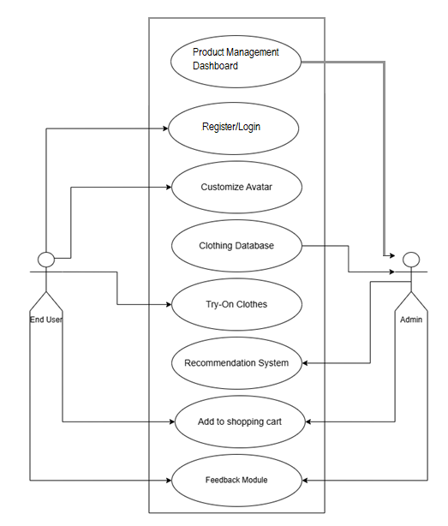

Figure 3.3 Use Case Diagram

#### Summary of Use Case Interactions

These seven use cases detail the End User engagement with the “Virtual Fit” System, from registering and generating an account to customizing the avatar, trying on garments virtually, receiving outfit recommendations, as well as adding products to the cart. Such interactions enable the user to have a full perception of what to purchase and what not to and at the same time, it provides the user with an interactivity throughout the shopping procedure.

## **Software Development Life Cycle Model**

The “Virtual Fit” project makes use of the Object-Oriented Methodology acronym as its SDL C. In OOM, data and functions are grouped into objects such as Avatar, User, Clothing Item this promotes modular and scalable as well as reusable.

#### ****Justification for Choosing OOM****

**Modularity and Reusability:**  
There are objects which comprise components, and therefore, it is easier to develop and test the components and reuse them, e.g., Avatar for customizing and visualizing.

**Scalability:**  
New features or objects can be added and do not usually cause a large problem for the existing systems.

**Clear Structure:**  
These look pro from a class and objects that make a clean design to boost the efficiency of comprehension and teamwork.

**Encapsulation:**  
Protects the internal information, and implies a reliable and authorized access to the system.

**Ease of Maintenance:**  
Access and limitations of individual objects could be altered without affecting the systems as a whole.

Thus, the nature of ‘Virtual Fit’ fits well with OOM because of flexibility, clear structure, and longevity excellently suitable for the project’s needs.

## Specific Requirements (Hardware and Software Requirements)

### Hardware Requirement

Here's the hardware components list for the **Virtual Try Room** system in a tabular form:

Table 3.5.1 Hardware Requirements

| **Component** | **Specification** |
| --- | --- |
| **CPU (Processing Power)** | Multi-core processor (Intel i7/i9 or AMD Ryzen 7/9) for handling complex computations and rendering |
| **GPU (Graphics Processing)** | Dedicated GPU (NVIDIA GeForce RTX or AMD Radeon RX) for 3D rendering and real-time graphics |
| **AI/ML Processing (Optional)** | NVIDIA Tesla or A100 GPU for AI acceleration if using machine learning for personalization/recommendations |
| **RAM (Memory)** | Minimum 16GB, recommended 32GB for handling large models and textures |
| **Primary Storage** | SSD with 512GB or 1TB for fast access to application files, textures, models |
| **Secondary Storage** | 2TB HDD or secondary SSD for additional data storage (e.g., user data, large assets) |
| **Display** | High-resolution monitor (at least 1920x1080p, preferably 4K) for viewing detailed textures and clothing fittings |
| **VR Headset (Optional)** | Oculus Rift, HTC Vive for immersive experience (if VR integration is included) |
| **Network (Internet)** | High-speed internet connection (minimum 100 Mbps) for real-time data synchronization and cloud-based services |
| **Input Devices** | Mouse, keyboard; optional touchscreen or pen tablet for precise interaction |
| **Webcam (Optional)** | For facial tracking or body measurements (if integrated with real-time avatar scanning) |

### Software Requirement

Table ‎3.5.2 Software requirements

|  |  |  |  |
| --- | --- | --- | --- |
| **Tools And Technologies** | **Tools** | **Version** | **Rationale** |
| Visual Studio Code | 1.92.2 (2024) | IDE |
| Blender | 3.6 LTS | 3D Software |
| Apache | 2.4.x | Web Server |
| MySQL | 8.0 | DBMS |
| Git | 2.41 | Version Control |
| MS Power Point | 2021 | Presentation |
| Figma | 2024 | Web Design |
| Node JS | 2024 | Backend |
| **Technology** | **Version** | **Rationale** |
| HTML | 5 | Website markup |
| CSS | 3 | Web Design |
| JS | ES2023 | Web Functionality & 3D Rendering |
| PHP | 8.2 | Backend |

# SOFTWARE DESIGN SPECIFICATION

## Design Models

Following this we have used Object Oriented Methodology (OOM) to design our system so that it can grow in scale, can be made modular and can be maintained easily. Thus, this methodology permits us to sequence the project around specific objects, with its respective data and functionality, and thus permit us to remove, replace, extend, and reuse said objects. We use Modular Design in addition to the OOM, to separate out several components, such as virtual avatars and clothing items, which will be independently developed, tested and updated. Using Unified Modelling Language (UML) diagrams, we also use class and use case diagrams to visualize system interaction and help us better share design ideas among the team. Our virtual fitting room application being functional, adaptable and easy to extend is made safe with OOM, modular design and UML.

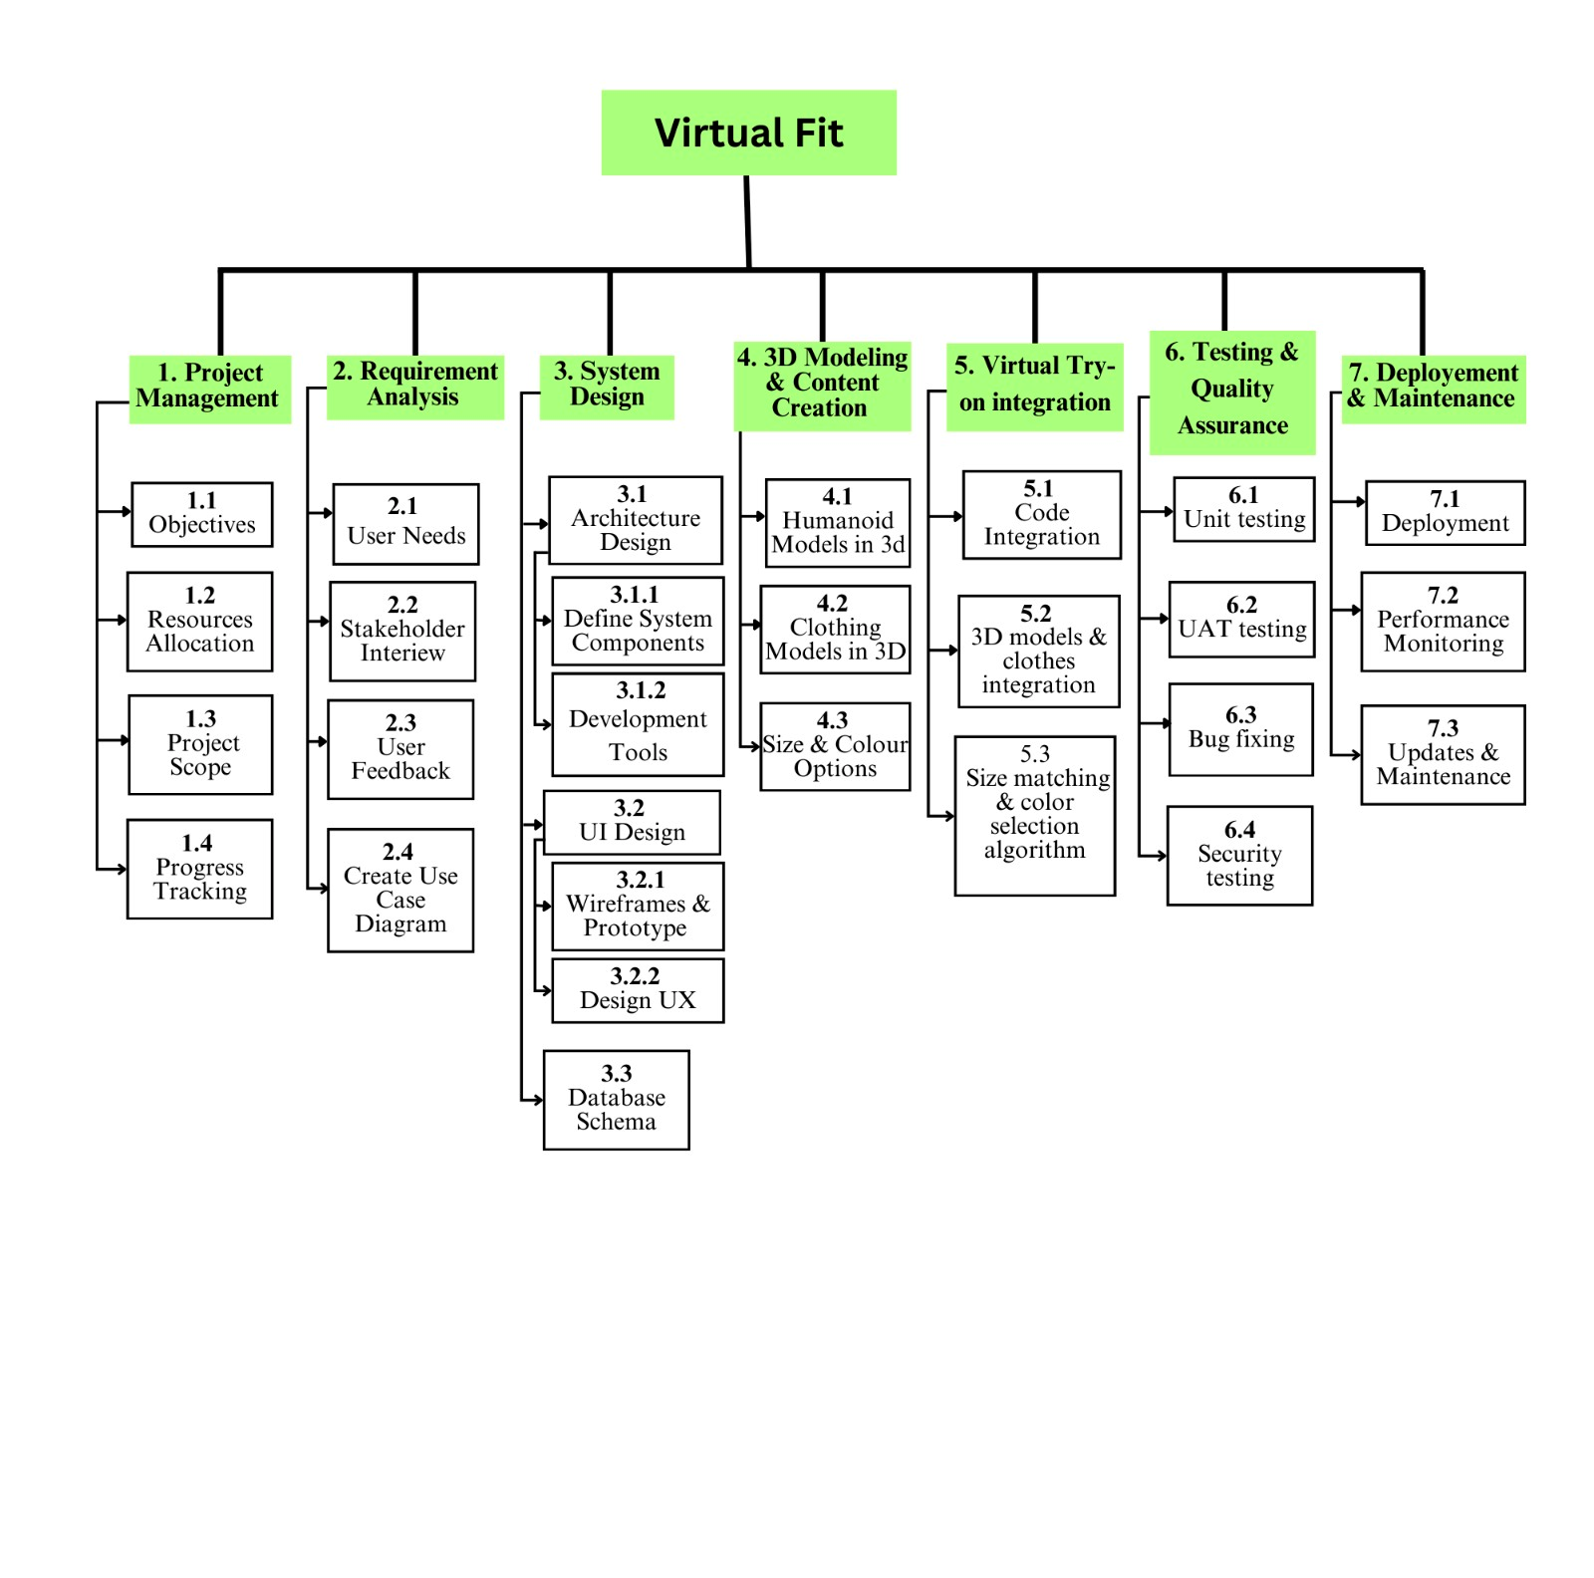

Figure 4.2 Work Breakdown Structure

## System Architecture

Virtual Fit has a robust, client server, architecture based on layered structure. This approach takes a strategic turn and divides the system into a user facing client and a backend server, indicating who should provide what in the system. Aligned with the client layer, where we work with technologies that help achieve smooth interaction and 3D rendering with end users, like three.js. Running critical operations such as processing the data, user authentication and communicating with the database for getting and managing the 3D apparel models and configurations is taken care of by the backend layer built in PHP and Node.js.

Both the simplicity of development promoted by modularity and the system's scale and maintainability are enhanced by this layered architecture, which assures that each component can be updated or replaced independently. For example, something such as clothing models or avatar customizations updates can be easily merged with the backend without being included in the client experience.

Our approach encapsulates predictability and stability by adopting a structured, layered architecture. This permits the progression of development in a by design manner, each layer of the architecture being meticulously designed to adhere to the project’s functional and non functional requirements. This results in a flexible, scalable, and efficient system delivering a superior virtual try on experience that maintains the potential for future growth and innovation.

### Block Diagram

**1.Login/Registration Block:** This block creates user account and implements login function along with a browse way to select available apparel options.

**2.Product Management Block:** Within this block, items can be filtered by size or colour, added to the shopping cart and tried on virtually.

**3.Virtual Try-On Block:** It renders virtual 3D representation of some selected items and enables choosing the best fit and purchase.

**4.Payment Processing Block:** It allows you to send this payment smartly and securely, confirm the order, and each successful transaction will have a receipt here.

**5. Order Confirmation Block:** The block ensures that order details, tracking delivery status and get feedback service is delivered to users.

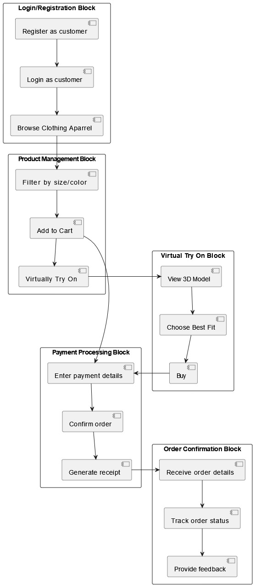

Figure 4.2.1 Block Diagram

### Component Diagram

A modular e-commerce system for a virtual clothing store component diagram is shown. Each module has a distinct role, and their interactions ensure smooth functionality:

**1. Virtual Fit System:** It offers the opportunity for users to try on the clothing virtually getting the fit just right. It fetches user data from database and talk to user interface.

**2. Cart System:** Via the database (it controls the operations over the cart; e.g., adding / removing items in the cart), it exposes the cart data.

**3. Payment Module:** Its job is to make payments, the cart system communicates on this, and updates the data base with payment related data.

**4. Recommendation Engine:** It’d fetch data from the user and cart from the database and send the user recommendations and show them with the user interface.

**5. Clothing Catalog:** Will suggest some possible clothing items to pick and to filter. Here it requests clothing datas from database and changes UI.

**6. User Interface:** This primary touch point for our users was rolling out registration, login, browsing, and spins with various modules including a virtual fit system, cart system, and clothing catalog. It is used for authenticating users and smoothing data flow.

**7. Database:** A central storage unit for all data of the user, clothes’ detail, cart data, payment records, and recommendation results. It supports all other components.

**8. Admin Module:** It gives tools for controlling users, clothing and system logs. Updates and retrival is done directly with database.

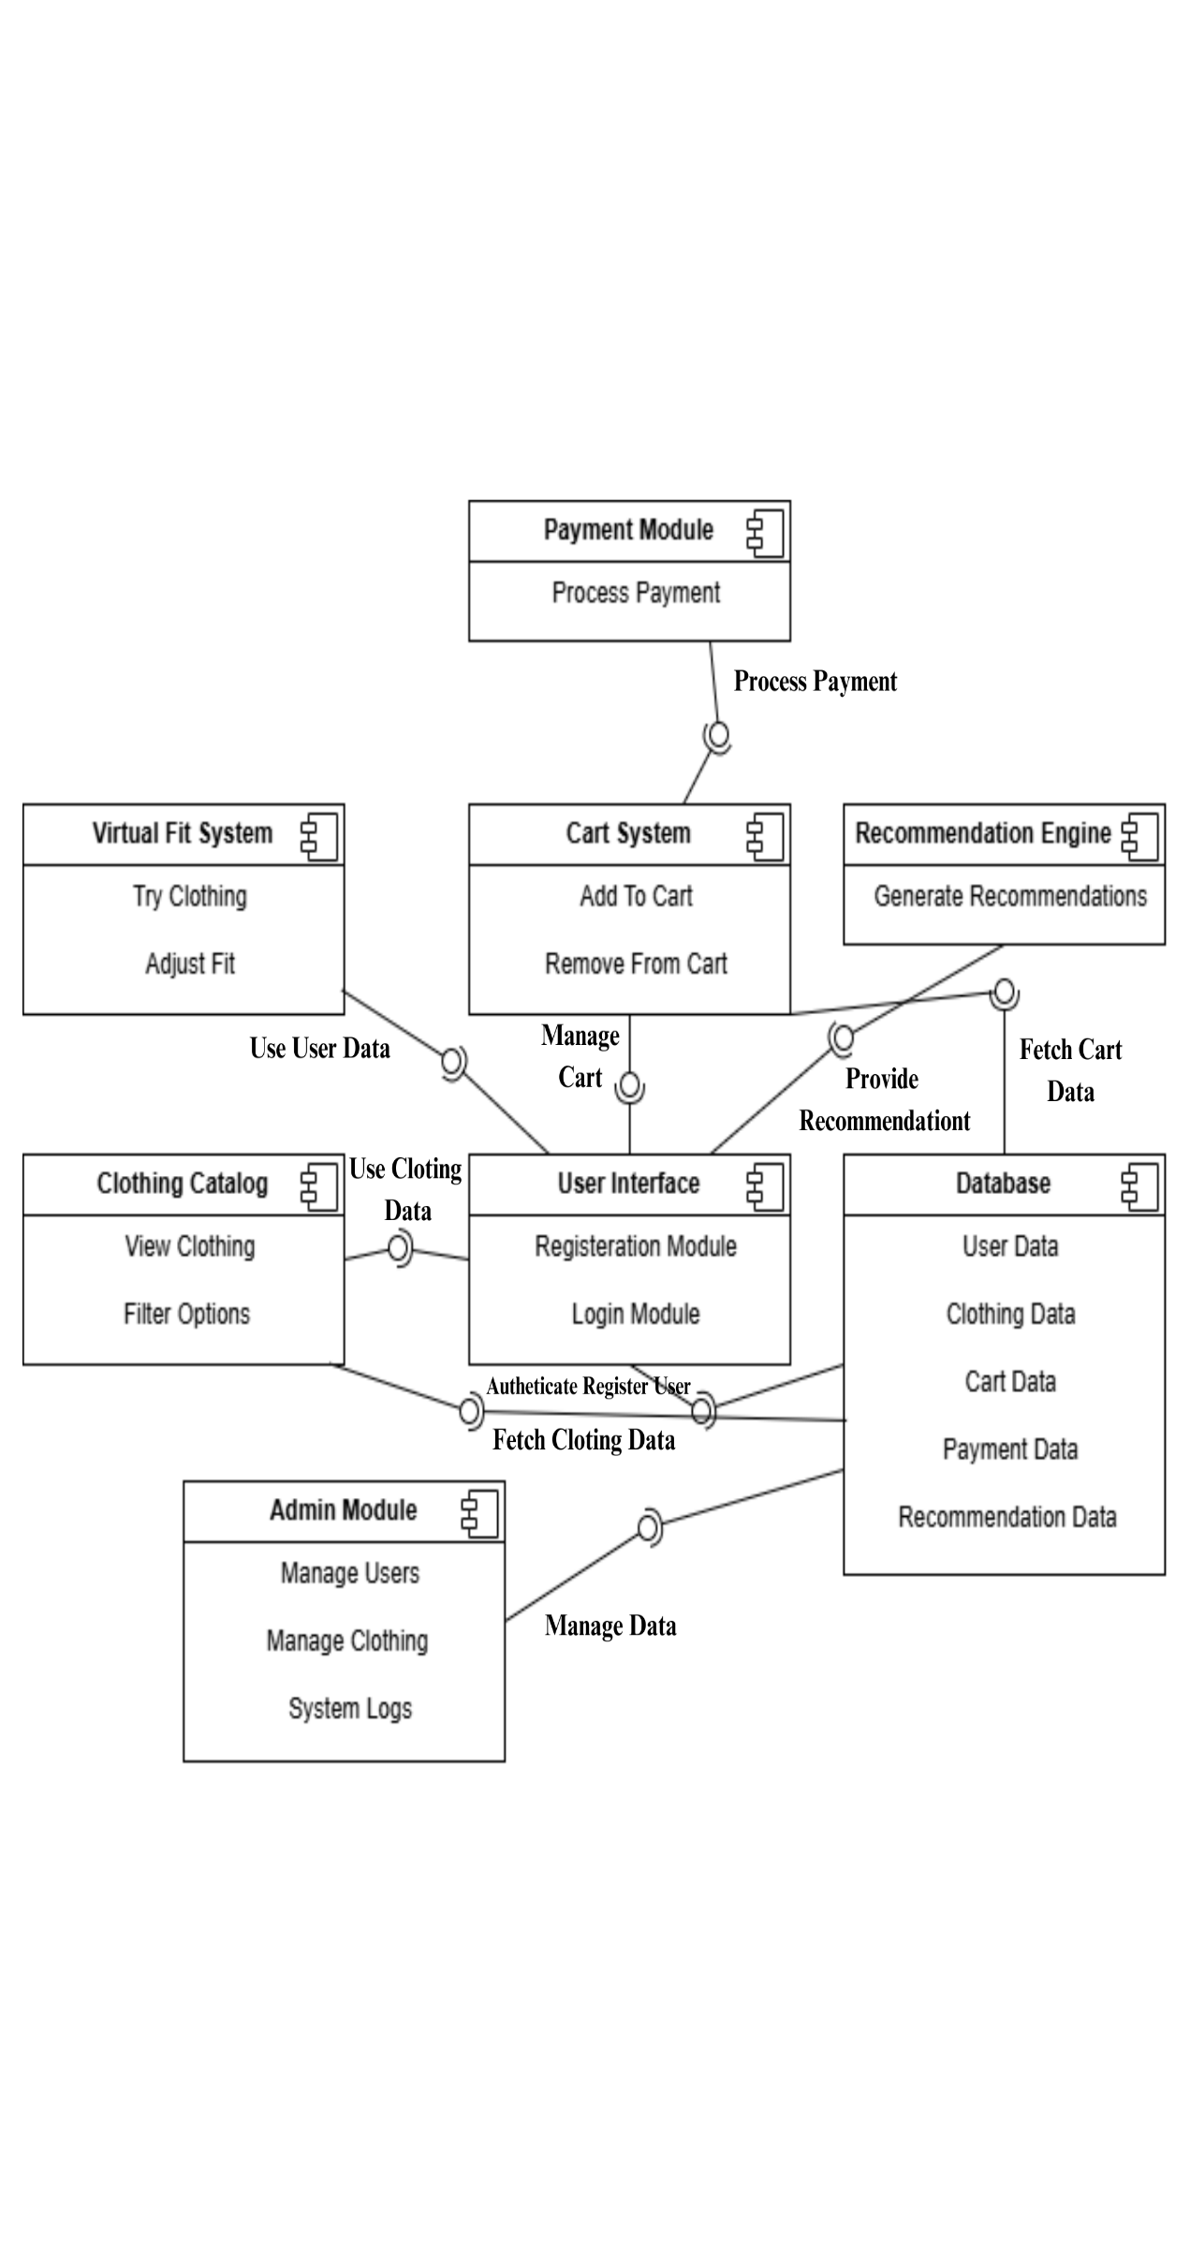

Figure 4.3.2 Component Diagram

### Software Architecture Diagram

**1. Presentation Layer:** This layer takes care of all avatar customization, virtual try-ons and outfit suggestions that are seen by the user.

**2. Application Layer:** This layer covers the application logic that is performed in virtual try on and creates service logic that enhances the user experience with service such as giving suggestions.

**3. Data Access Layer:** It is this layer that acts as a middle ware passing the data from application layer to server layer efficiently.

**4. Data Server Layer:** It provides secure storage and retrieval of critical data with high performance and reliable.

**5. External Integration:** This layer is to make sure that payments and transactions integrate smoothly with external systems.

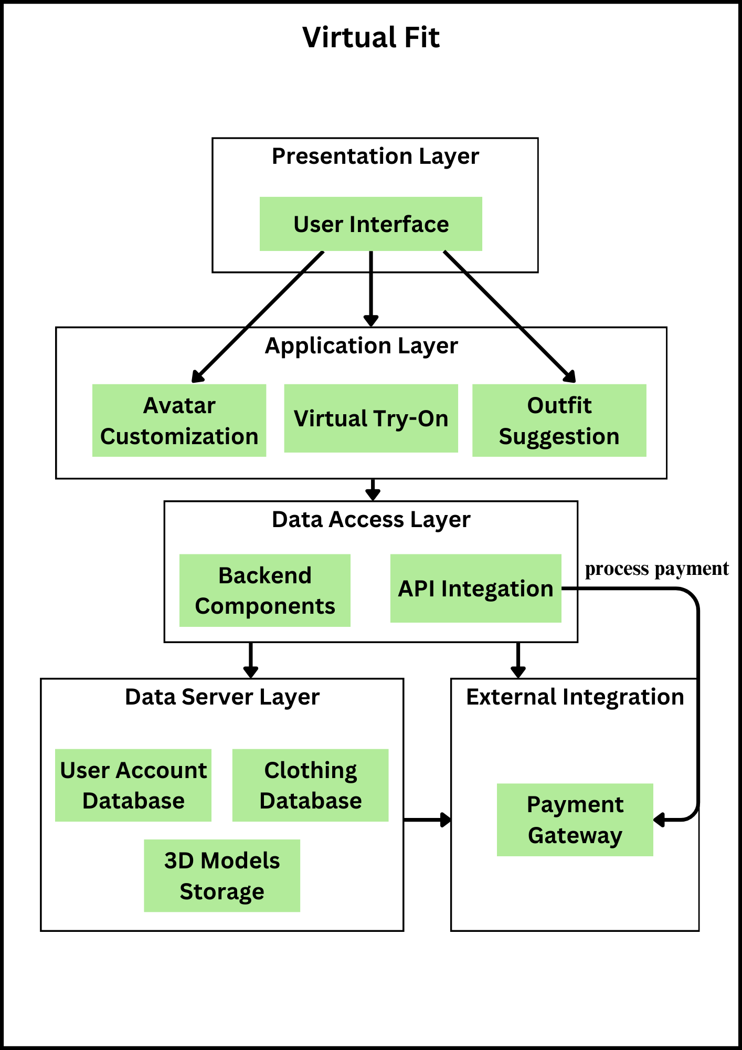

Figure 4.3.3 Software Architecture Diagram

## Data Representation [Diagram + Description]

### Entity-Relationship Diagram (ERD)

**1. Users:** Users log in and place orders, try on products virtually, and provide feedback.

**2. Categories:** With the attributes, the Categories entity classifies products into different groups. It makes products easier to organize, for better browsing.

**3. Products:** Contained in Products entity is information regarding the items available for virtual try on and purchase.

**4. Virtual Try-On:** Virtual Try On entity points user to the product they try virtually.

**5. Cart:** Items that users want to buy are stored by the Cart entity.

**6. Orders:** User purchases are maintained by the Orders entity. It is to keep a record of transactions organized for the users and administrators.

**7. Order Details:** It’s detailed, it gives you insight into what’s going on in individual orders.

**8. Payment:** Each order is written on each order through the Payment entity.

**9. Feedback:** Feedback is a entity that creates a row to rate and review products.

**10. Recommendations:** The main recommendation we can give is available through Recommendations entity.

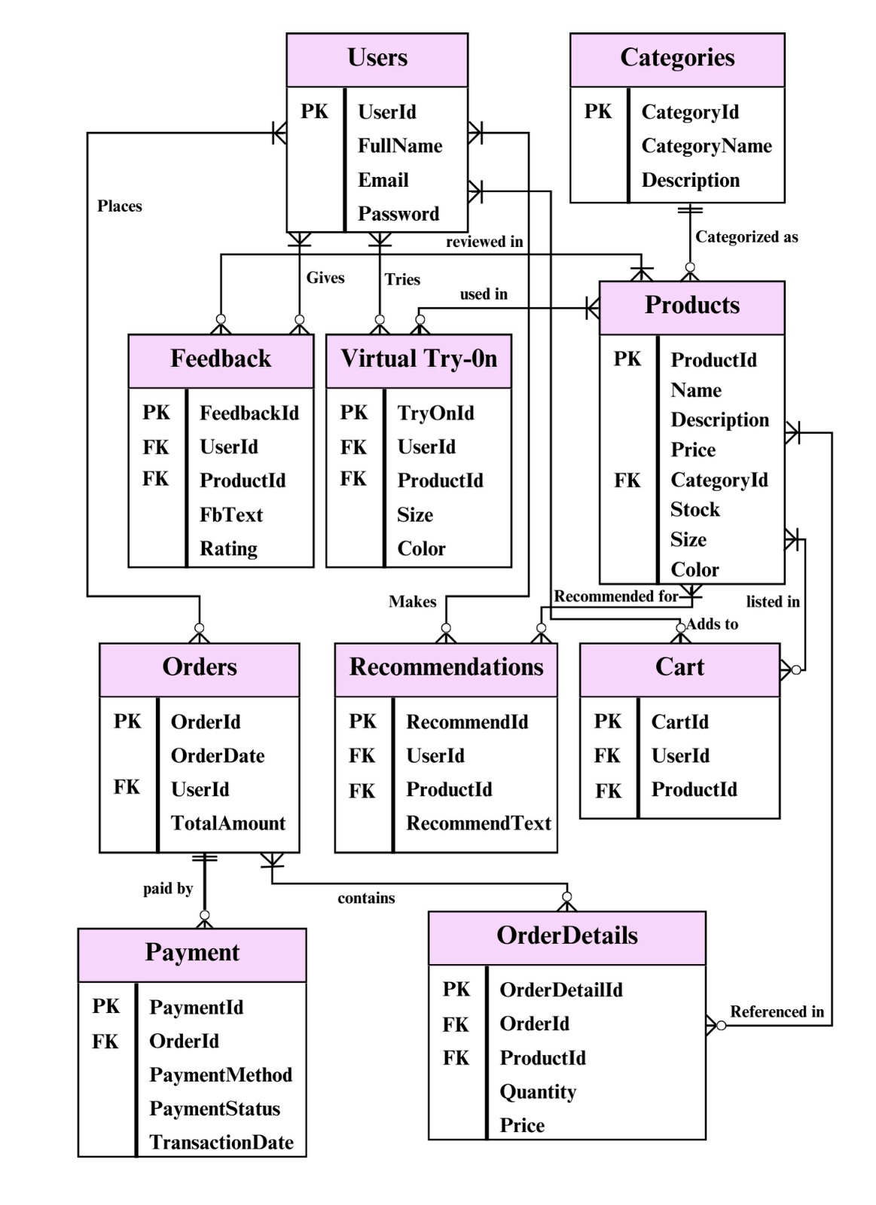

*Figue 4.4.1 Entity-Relationship Diagram*

### UML Class Diagram

**1. Categories:** Defines product categories and groups the products within these product categories into specific groupings.

**2. Products:** Handles all information pertaining to the product, such as the stock, size and attributes for sales.

**3. Users:** It has user management functionalities, managing creating and maintaining accounts for using the application.

**4. Orders:** Keep records on customer orders from placing through cancellation.

**5. Feedback:** Feedback and ratings of customers captures insights to provide product satisfaction.

**6. Virtual Try-On:** It allows a user to productively see products virtually for a better shopping experience.

**7. Recommendations:** Based on users preferences and measurements it generates personalized product suggestions.

**8. Cart:** It controls how products should be added, removed, updated for checkout preparation.

**9. Payment:** They secure payment details for you and make sure the transactions happen.

**10. OrderDetails:** It gives a clear information about each order, like the product amount and total price.

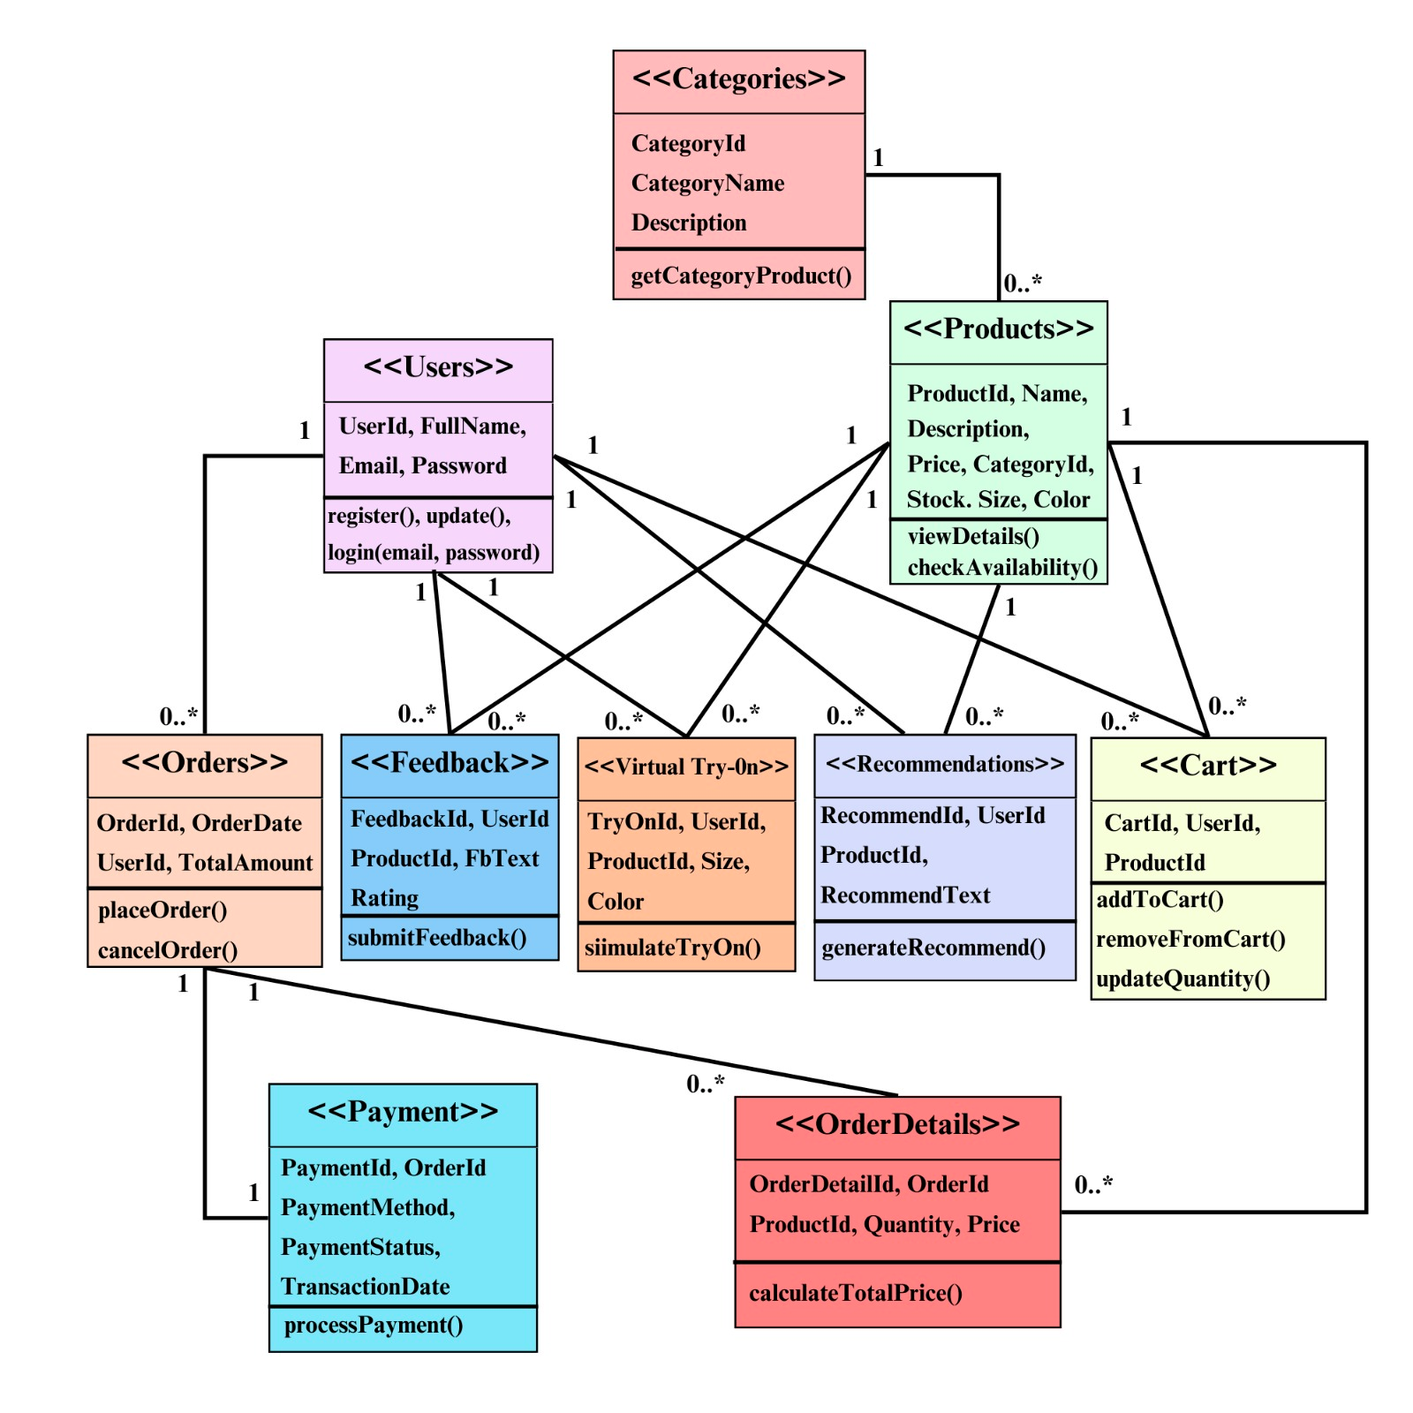

*Figure 4.4.2 UML Class Diagram*

### Data Flow Diagram (DFD)

**1. User Database:** Stores user information for login and registration.

**2. Cart Database:** It also keeps data regarding cart per users.

**3. Product Database:** Offers product details for browsing, try on browsing, and order placement.

**4. Order Database:** Orders of collections or a single unit are tracked on payment and shipping status.

**5. Payment Database:** Logs payment confirmations and transaction history.

**6. Feedback Database:** Stores customer feedback and ratings.

**7. Recommendation Database:** It handles personalized recommendation, given feedback and preferences.

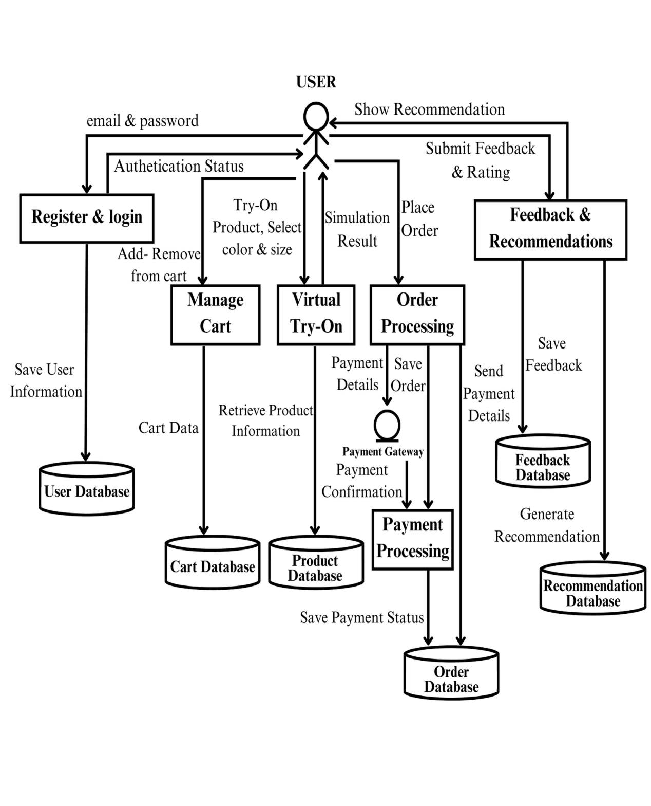

*Figure 4.4.3 Data Flow Diagram*

### Hierarchical Diagram

**1. Front End:** This section focuses on the user-facing features, enabling a seamless shopping and interaction experience.

**2. Back End:** The backbone of the application, managing data and business logic.

**3. Admin Tools:** These tools provide administrative control over the app's operations.

*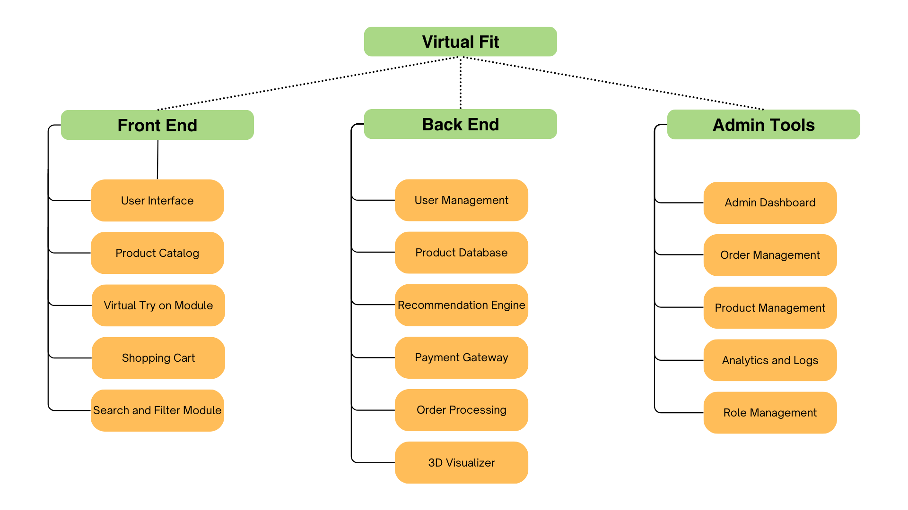Figure 4.4.4 Hierarchical Diagram*

## Process Flow/Representation

### Flowchart

The Virtual Fit system starts by having users visit the platform and to log in or register should they’ve never logged in. For new users they can register giving their account details and body measurements, while existing users log in and redirect to your homepage. When a user browses the catalog they select a product and view the details, with the option to use the Virtual Try-On for a simulated fit of that product according to the user’s measurements. Users then fill in their payment and shipping information and submit them to proceed to checkout. Order is confirmed through successful payments, and failed payments ask the users to retry, which display the order confirmation screen.

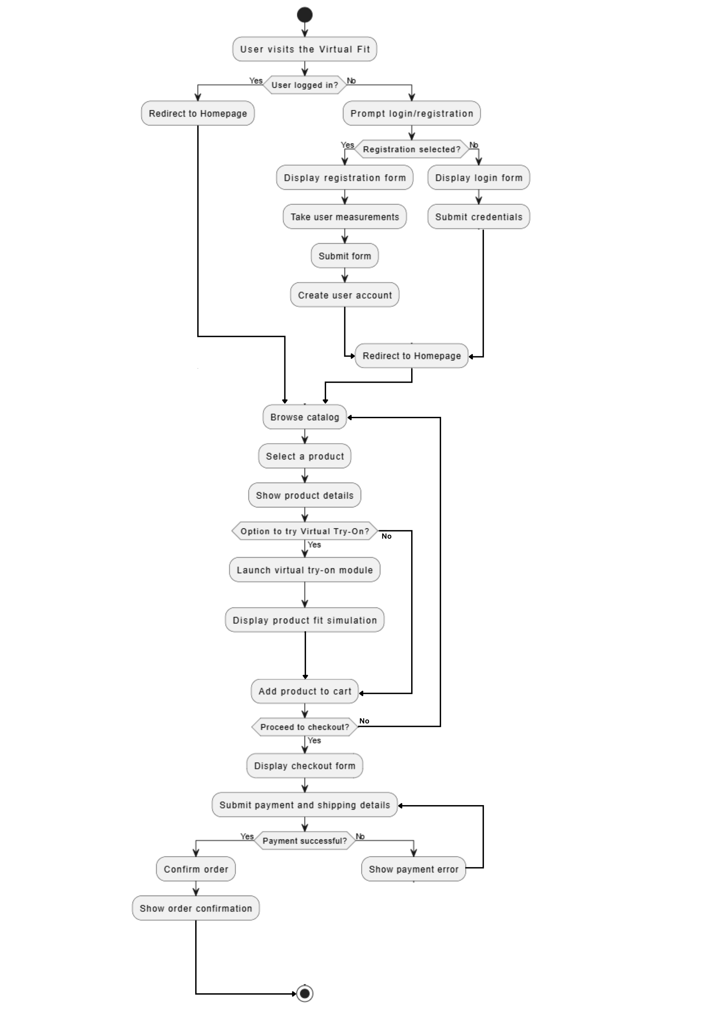*Figure 4.5.1 Flowchart*

### Sequence Diagram

**User Sequence Diagram Description:**

The user sequence diagram is laid out, illustrating the flow from a user to the Virtual Fit system. Then they choose what product they want to hear explained about, and they launch the app. In product database, it shows the product information and fetches the product. The system checks for availability when the user picks Virtual Try On. The Virtual Try On module function will provide a fit simulation based on the user measurements if it’s called and will display an error message otherwise. Users can then add product to their cart, checkout or continue shopping.

**Admin Sequence Diagram Description:**

Admin sequence diagram define how the administrators control the system by Admin Dashboard. After logged admin can add or update product information, which is stored in the product database and a confirmation message is shown. Required by admins as well: It enables user to view activity/user reports on the basis of data fetched and reported. The probably best place to start is setting things up so that you can update and save system settings with confirmations. The admins finally could log out, and the log out operation was confirmed by the system.

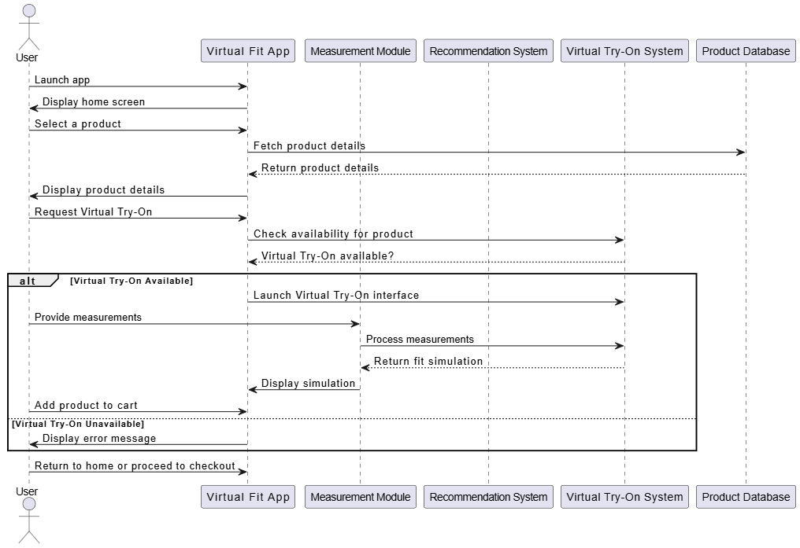

Figure 4.5.2.1 User Sequence Diagram

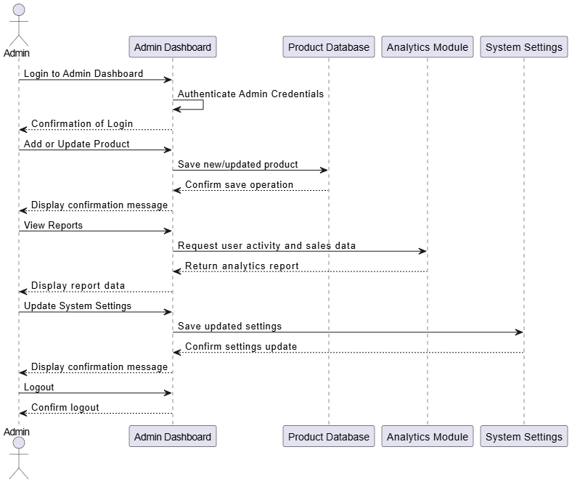

Figure 4.5.2.2 Admin Sequence Diagram

### Activity Diagram

**User Activity Diagram Description:**

Users create a profile, log in to browse products, check try-on availability and use if it’s available. They select the products they go on payment after that. If a payment succeeds, the order has been confirmed, in case of error the user is redirected to the try payment or to browse them again.

**Admin Activity Diagram Description:**

While a user logs in to the dashboard, they can add new products, update existing products or only benefit from dashboard reports and update all system settings, except that all actions will be confirmed. They can even log out and access analytics about user activity and sales data.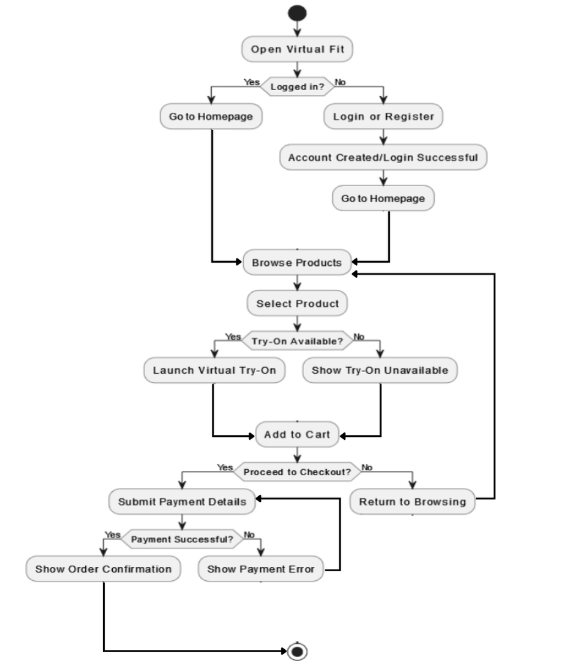*Figure 4.5.3.1 User Activity Diagram*

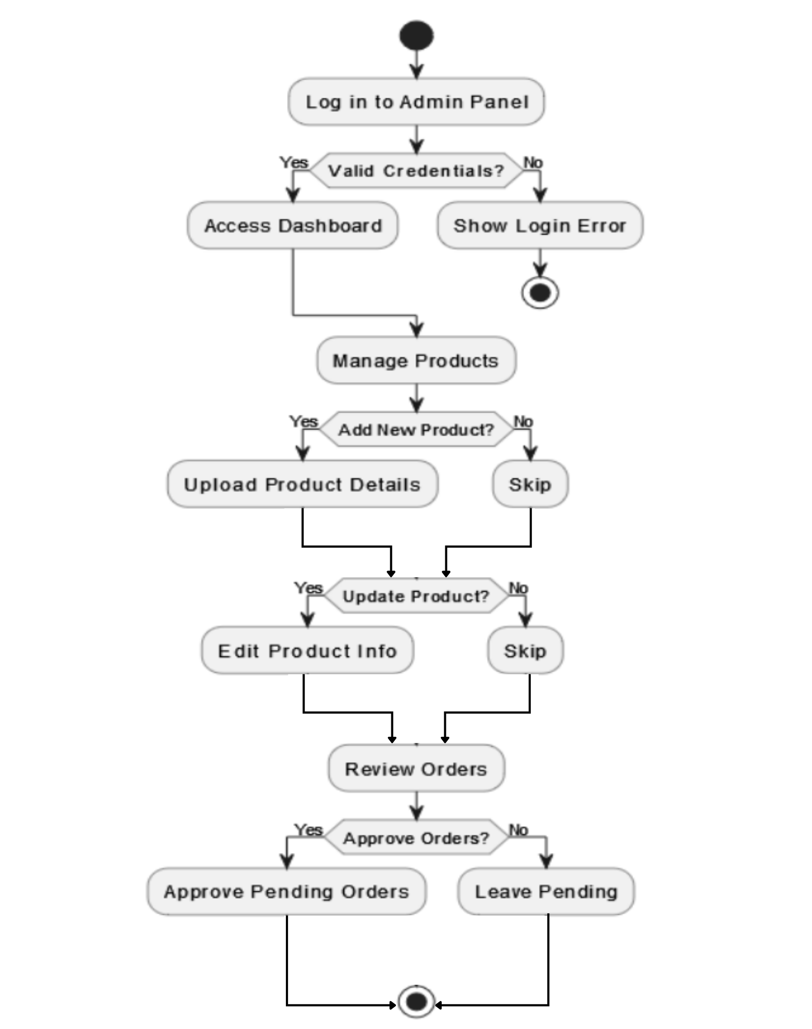

Figure 4.5.3.2 Admin Activity Diagram

# IMPLEMENTATION

## Algorithm

The core logic of the "Virtual Fit" system is based on conditional selection to dynamically display a pre-defined 3D model that matches the user's preferences. Since our project utilizes pre-made 3D models with different attributes (gender, body type, skin tone, clothing), the system selects the correct model using simple yet effective conditional statements.

The algorithm works in two main parts:

1. Model Selection Algorithm
2. Color Mapping Algorithm

**Model Selection Algorithm:**

The system follows a step-by-step approach:

1. Check user’s selected gender.
2. Based on gender, check skin tone.
3. Based on skin tone, check body type.
4. Based on body type and clothing selection, load the respective pre-made 3D model.

**Pseudocode:**

function selectModel(gender, skinTone, bodyType, shirtColor) {

let modelName = '';

if (gender === 'male') {

if (skinTone === 'white') {

if (bodyType === 'slim') {

modelName = 'White_Male_Slim_' + shirtColor + '_Shirt';

} else if (bodyType === 'fat') {

modelName = 'White_Male_Fat_' + shirtColor + '_Shirt';

}

} else if (skinTone === 'black') {

if (bodyType === 'slim') {

modelName = 'Black_Male_Slim_' + shirtColor + '_Shirt';

} else if (bodyType === 'fat') {

modelName = 'Black_Male_Fat_' + shirtColor + '_Shirt';

}

}

} else if (gender === 'female') {

if (skinTone === 'white') {

if (bodyType === 'slim') {

modelName = 'White_Female_Slim_' + shirtColor + '_Shirt';

} else if (bodyType === 'fat') {

modelName = 'White_Female_Fat_' + shirtColor + '_Shirt';

}

} else if (skinTone === 'black') {

if (bodyType === 'slim') {

modelName = 'Black_Female_Slim_' + shirtColor + '_Shirt';

} else if (bodyType === 'fat') {

modelName = 'Black_Female_Fat_' + shirtColor + '_Shirt';

}

}

}

loadModel(modelName);

}

**Explanation:**

* This algorithm selects the model dynamically using the combination of the user's choices.
* Each model is pre-named accordingly, so the function builds the model filename string and loads it.

**Color Mapping Algorithm:**

The second algorithm is responsible for determining the best complementary color combinations for apparel. For example, selecting pants color based on the chosen shirt color.

**Pseudocode:**

function suggestPantsColor(shirtColor) {

let pantsColor = '';

if (shirtColor === 'black') {

pantsColor = 'red'; // Black shirt looks good with red pants

} else if (shirtColor === 'blue') {

pantsColor = 'white'; // Blue shirt pairs well with white pants

} else if (shirtColor === 'white') {

pantsColor = 'blue'; // White shirt can go with blue pants

} else {

pantsColor = 'black'; // Default choice

}

return pantsColor;

**Explanation:**

* The algorithm checks the selected shirt color and maps it to a complementary pants color.
* The color choices are based on common fashion standards and can be expanded in future updates.

**Advantages of This Approach:**

* Simple and efficient to implement.
* No need for external processing or AI.
* Flexible: easily expandable by adding more conditions.

## External APIs

Through its integration with external APIs the "Virtual Fit" system improves functionalities to create a better user experience.

**1. Three.js CDN**

* **Purpose:**  
  The browser needs this API to show 3D models during rendering and loading processes. A strong 3D JavaScript library named Three.js allows users to import .glb models while actively showing them on the screen.
* **Integration:**  
  Imported directly via CDN in the HTML <script> tag.

<script src="https://cdnjs.cloudflare.com/ajax/libs/three.js/r128/three.min.js"></script>

* **Functionality:**

1. Handles loading pre-made avatar models.
2. Renders them interactively on the webpage.
3. Allows rotation, zooming, and animation.

**2. PayPal API**

* **Purpose:**  
  Virtual Fit incorporates PayPal API as its payment system for users to make secure online transactions of premium packages and digital purchases.
* **Integration:**  
  The PayPal JavaScript SDK serves as a web integration platform for customers.

<script src="https://www.paypal.com/sdk/js?client_id=placeholder"></script>

* **Payment Flow:**
  1. **Order Creation:**  
     A product order appears after the user selects "Pay with PayPal" through a system API request.
  2. **Order Approval:**  
     After the transaction request PayPal asks users to approve the payment.
  3. **Order Capture:**  
     The payment concludes after PayPal accepts the transaction.
* **Authentication:**  
  The system accepts PayPal client IDs from sandbox environments during testing and live environments for production.
* **Pricing:**

1. No upfront API cost.
2. Transactional fee: PayPal charges a percentage (approximately 2.9% + fixed fee depending on region) on every successful transaction.

* **Security Measures:**

1. HTTPS connection for all API calls.
2. Encrypted transactions.
3. Optional fraud detection features offered by PayPal.

* **Advantages:**

1. Trusted by users globally.
2. Easy integration.
3. Supports multiple currencies and countries.

## User Interface

### **UI Design and Layout**

Virtual Fit is a website designed with minimal and dynamic interface to ease the user shopping experience by allowing them to try-on clothes virtually. The layout is consistent across all pages.

### **5.3.1.1 Main UI Components**

* **Login/Signup Pages:** Simple input fields for gmail and password, signup page includes details of a user, such as waist, chest, skin tone, which I sessential for a 3d model.
* **Home/Shop Pages:** Home & Shop pages which consists of product cards, testimonials, header, footer and buttons redirecting to Try-On room, with easy flow among pages.
* **Virtual Try-On:** Try-On room, where a user can virtually try on the selected apparel, with additional option for selecting best matching outfit.
* **Cart Sidebar:** Sidebar where the selected apparel will be added to let user see what items they have selected and the description, quantity and price of products.
* **Contact Us:** Simple form where the user can drop a message after filling out the input fields, message can be a query, for career, or a complaint.
* **User Info:** All the saved details of the user will be stored here, which he can change manually whenever the user want.
* **Checkout:** Checkout page where user have to enter details, shipping address, billing address and select one of the given payment methods.

### **UI Development Tools and Technologies**

* **Programming Language:**  
  PHP, JS – for dynamically handling interactions
* **Layout Design:**  
  Html & Css – for designing front-end pages.
* **Framework & IDE:**  
  Visual Studio – used for UI development and backend integration.
* **Libraries & Tools Used:**
  + Three.js, Node Js
  + XAMPP
  + Blender
  + Git

### **User Interface Mockups**

* **Login/Signup:**

If already a user then simply by filling the input fields, user will be directed to home page, if not a user already, user can click on singup, to register.

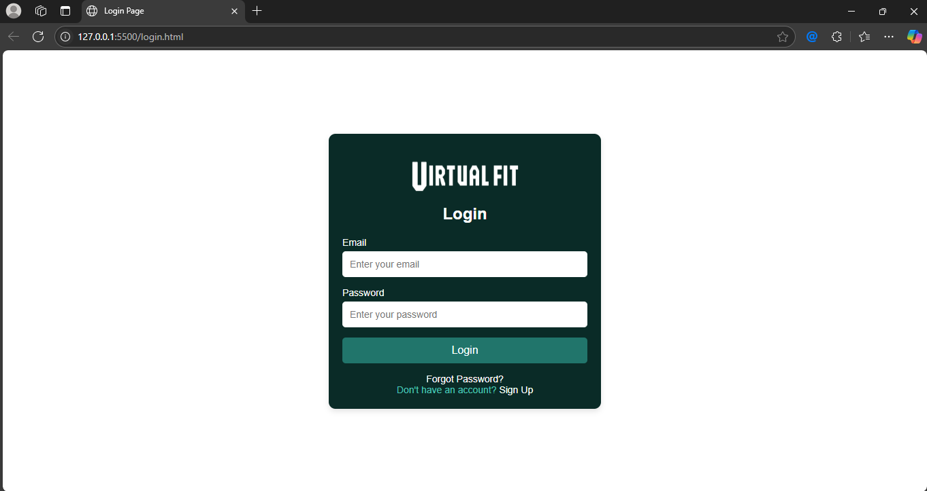

Figure 5.3.3.1 Login Page

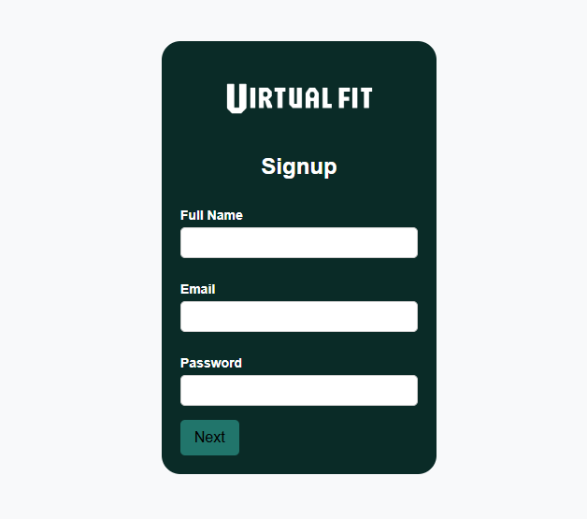

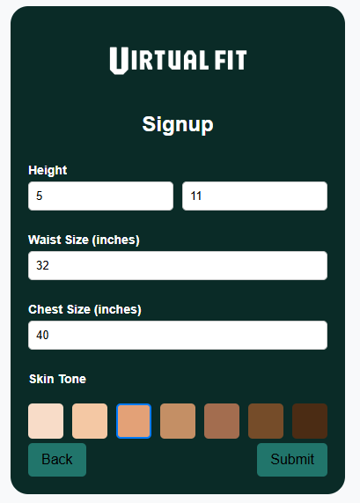

Figure 5.3.3.2 Signup Page

* **Home Page:**

It includes Header(NavBar) with menu option, in which shop is a drop down, then a cart and user option, below that is a hero section, which includes a virtual try on button, then it includes, collection divider, and product cards, then the testimonials and a footer which includes, newsletter.

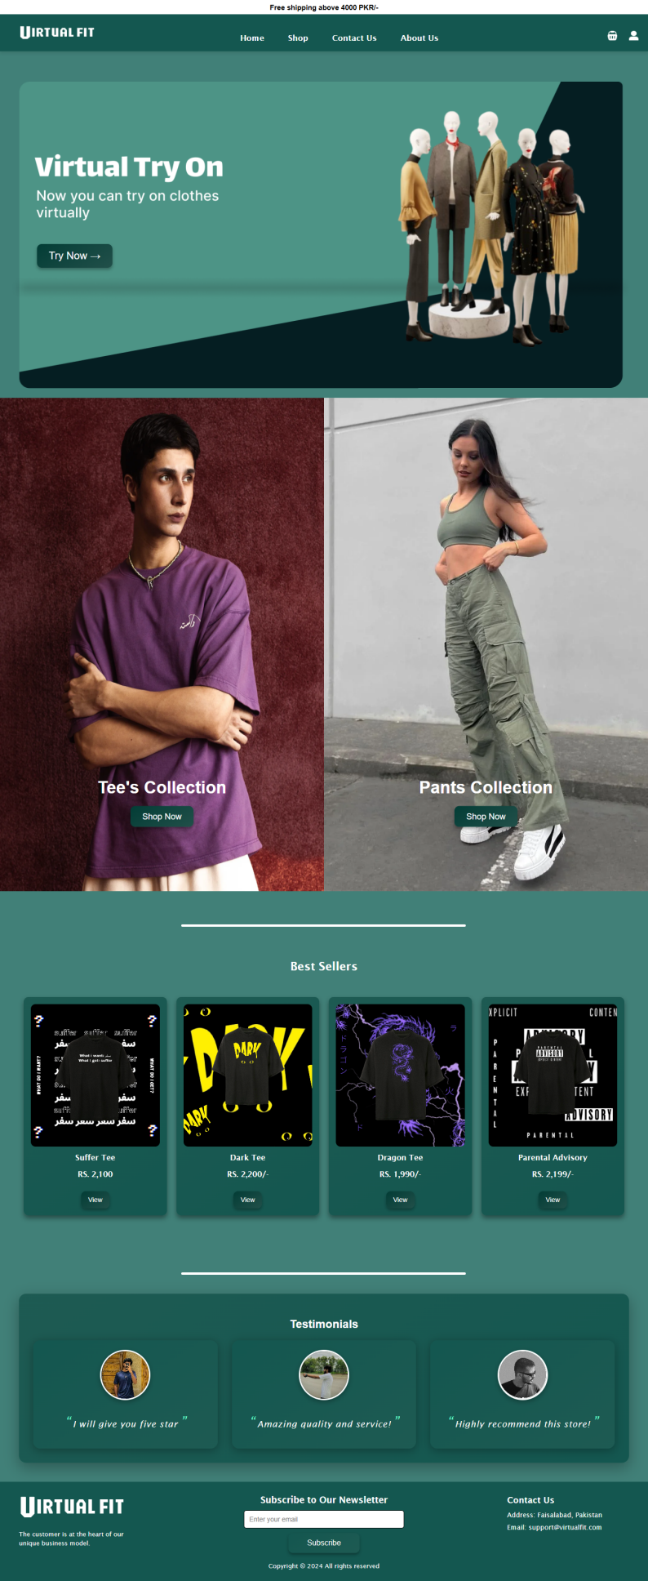

Figure 5.3.3.3 Home Page

* **Shop / Tee/ Pants Page:**

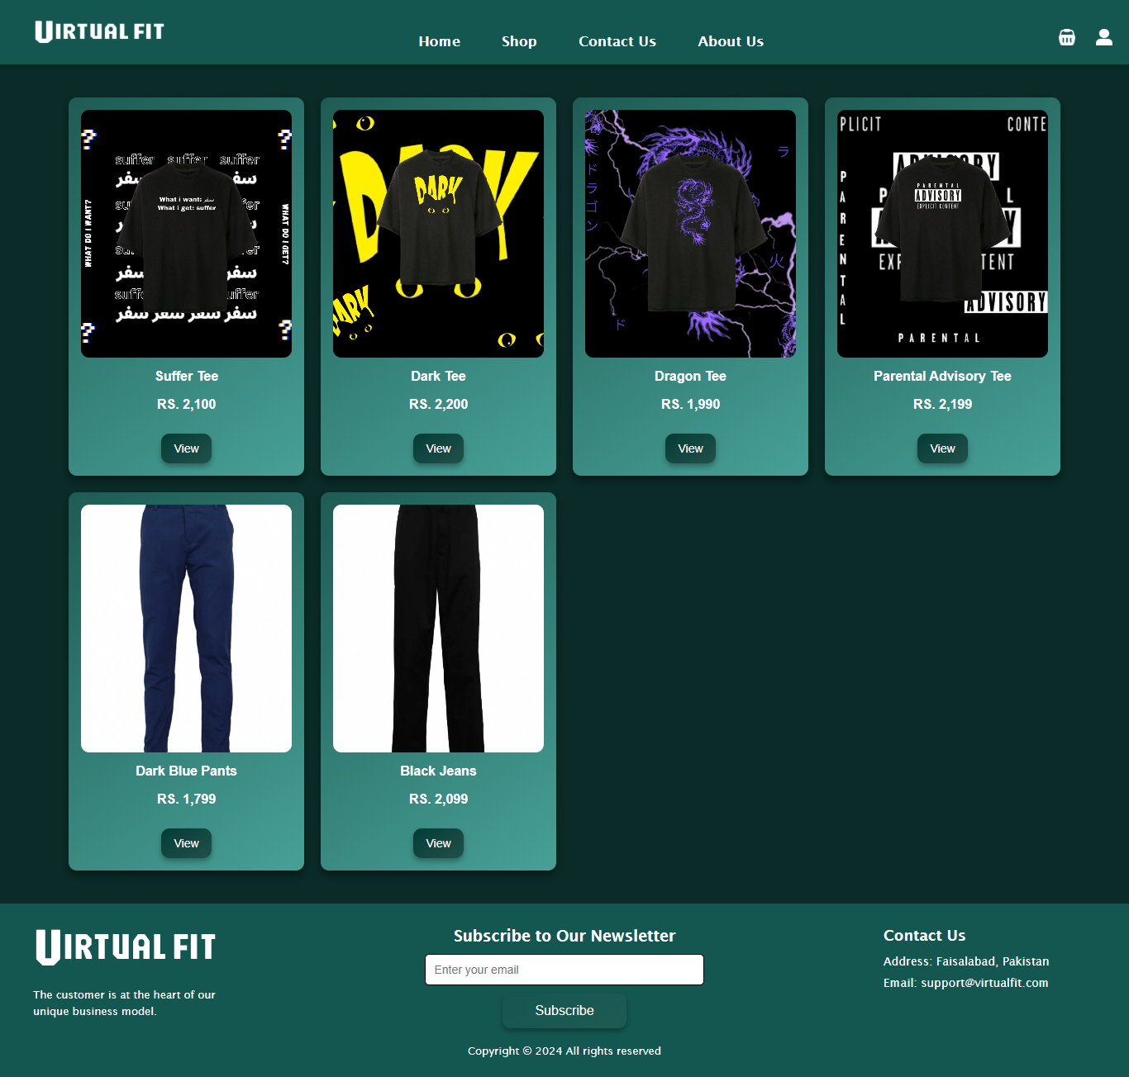

Figure 5.3.3.4 Shop Page

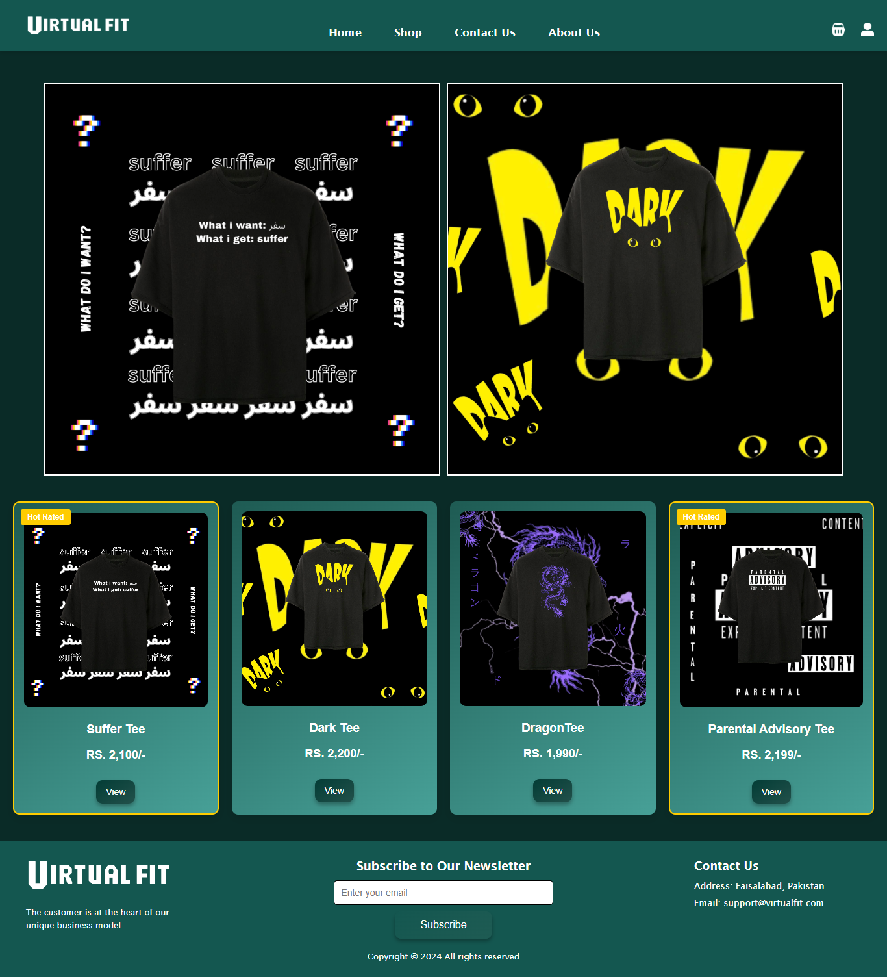

Figure 5.3.3.5 Tee Page

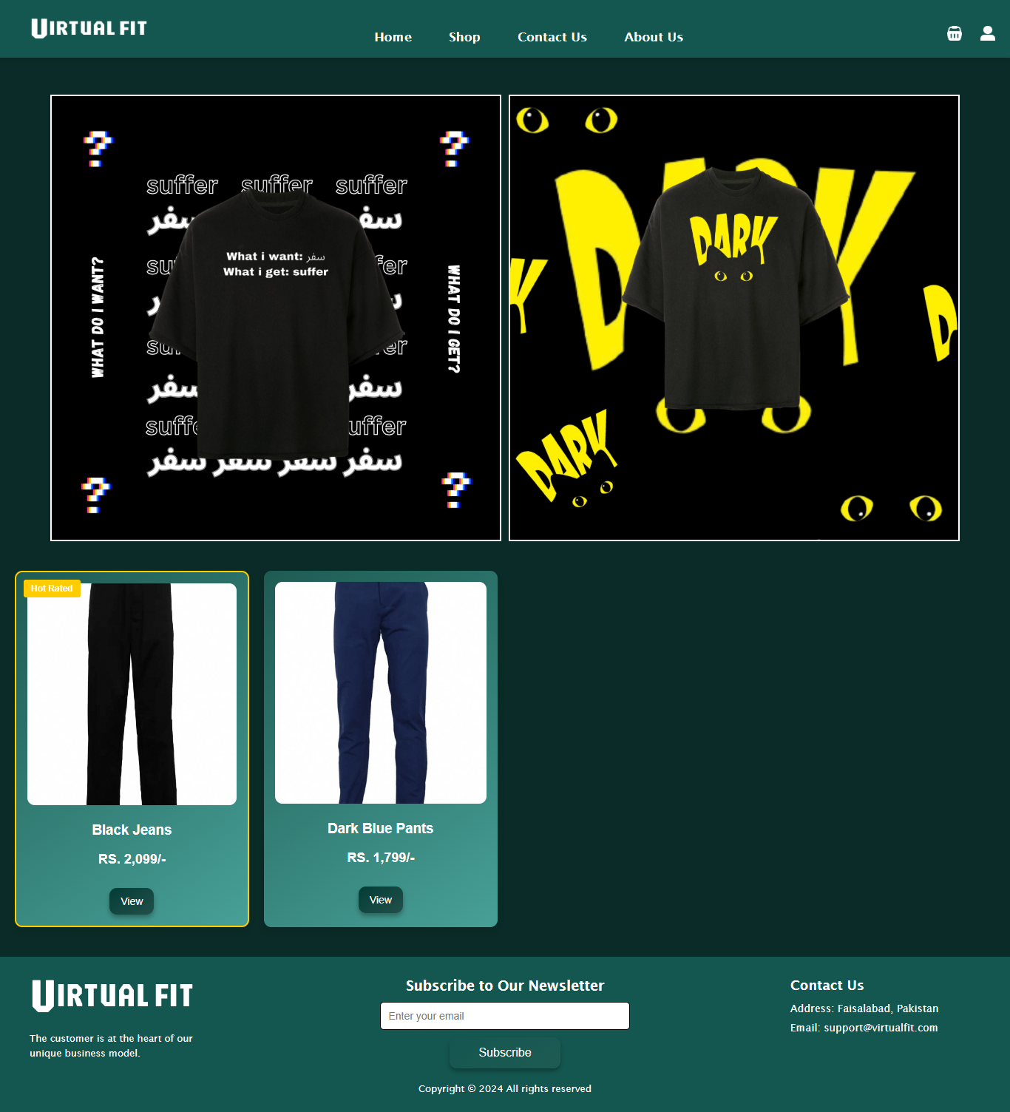

Figure 5.3.3.6 Pants Page

* **Contact Us:**

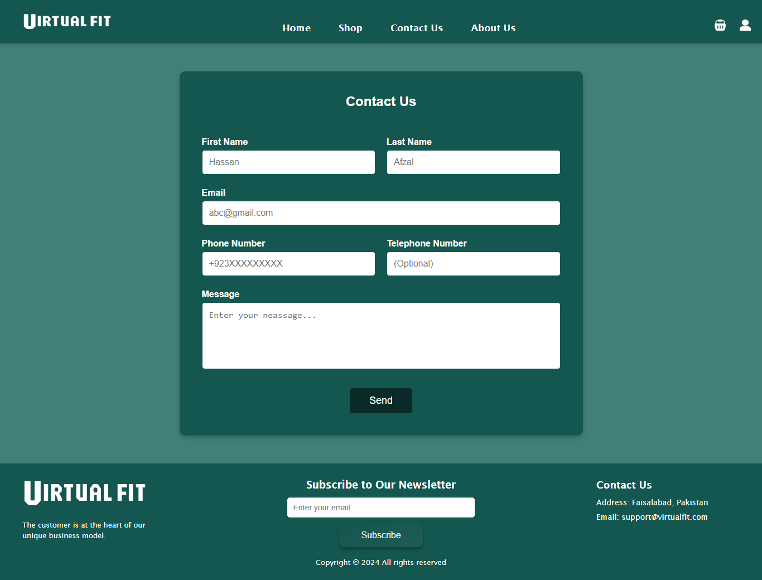

Figure 5.3.3.7 Contact Us

* **About Us:**

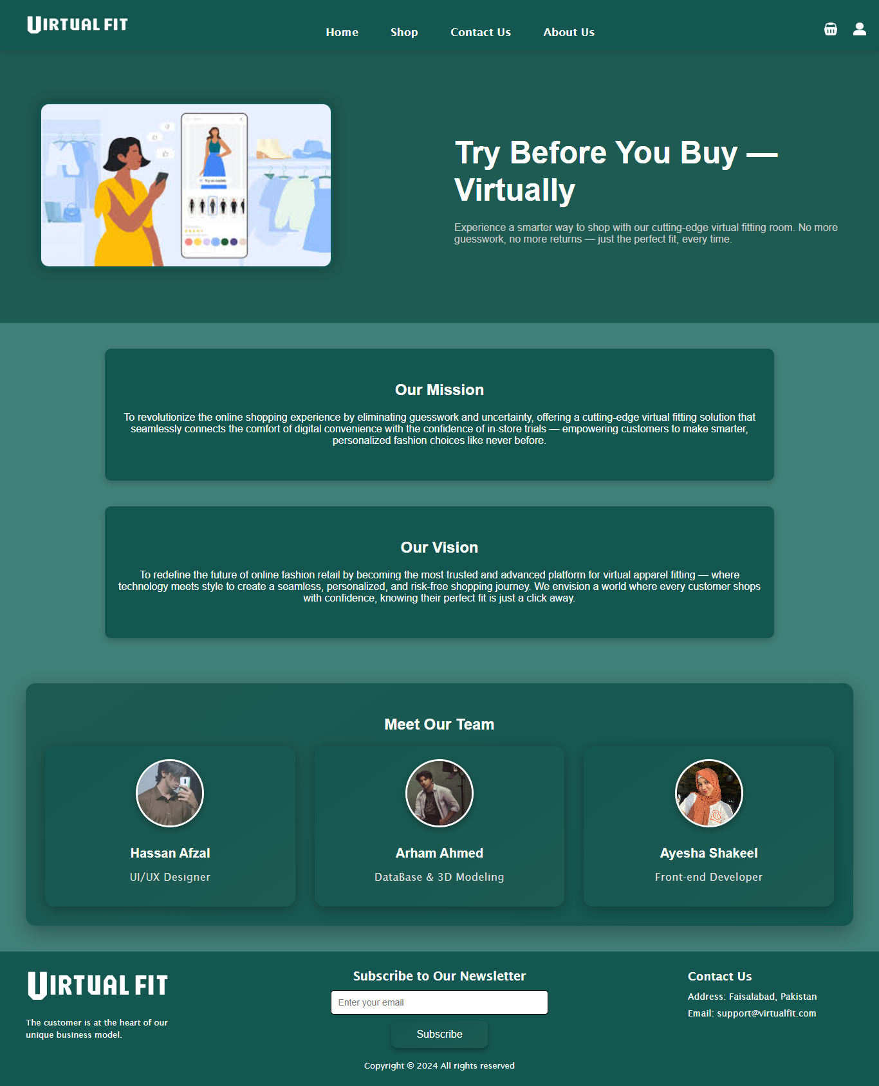

Figure 5.3.3.8 About Us

* **Cart:**

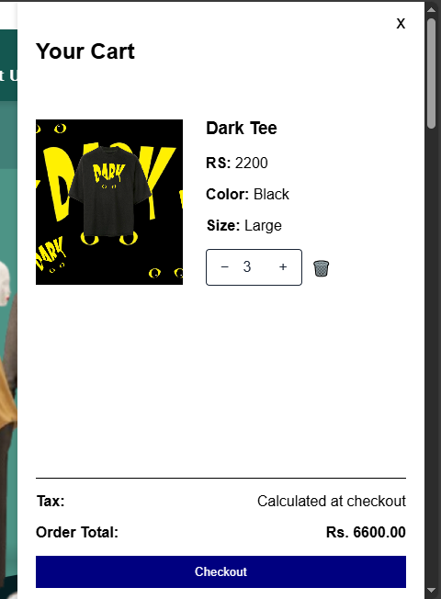

Figure 5.3.3.9 Cart

* **User Account:**

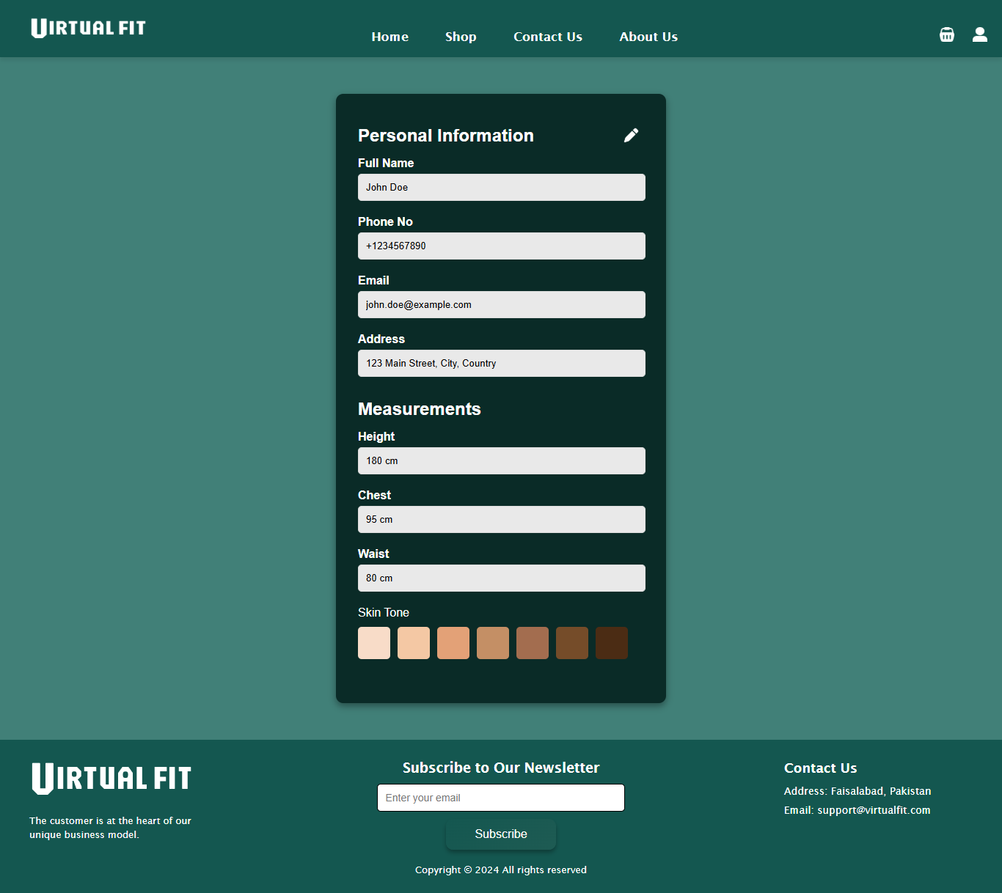

Figure 5.3.3.10 Account

* **Product Description:**

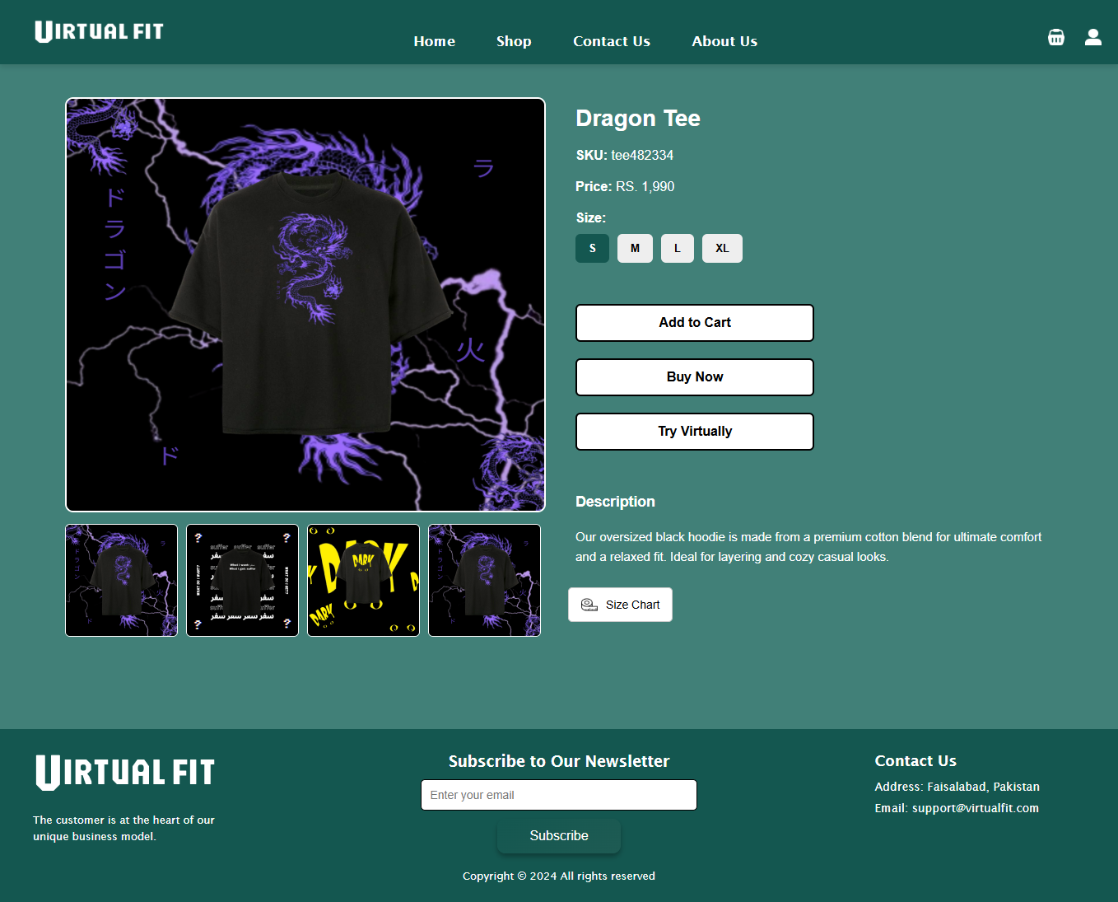

Figure 5.3.3.11 Product Description

* **Try-on Room:**

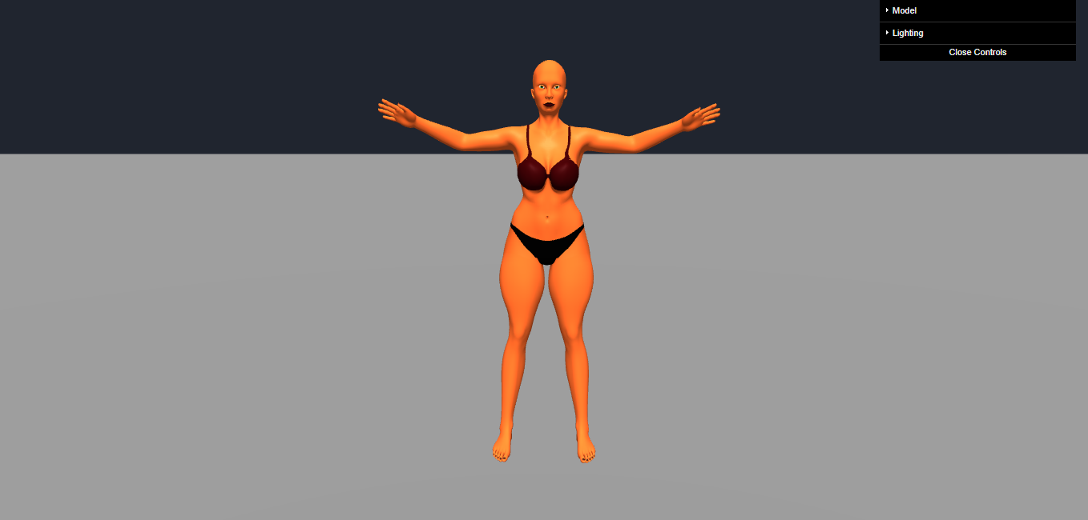

Figure 5.3.3.12 Try-On Room

* **Try-on Room:**

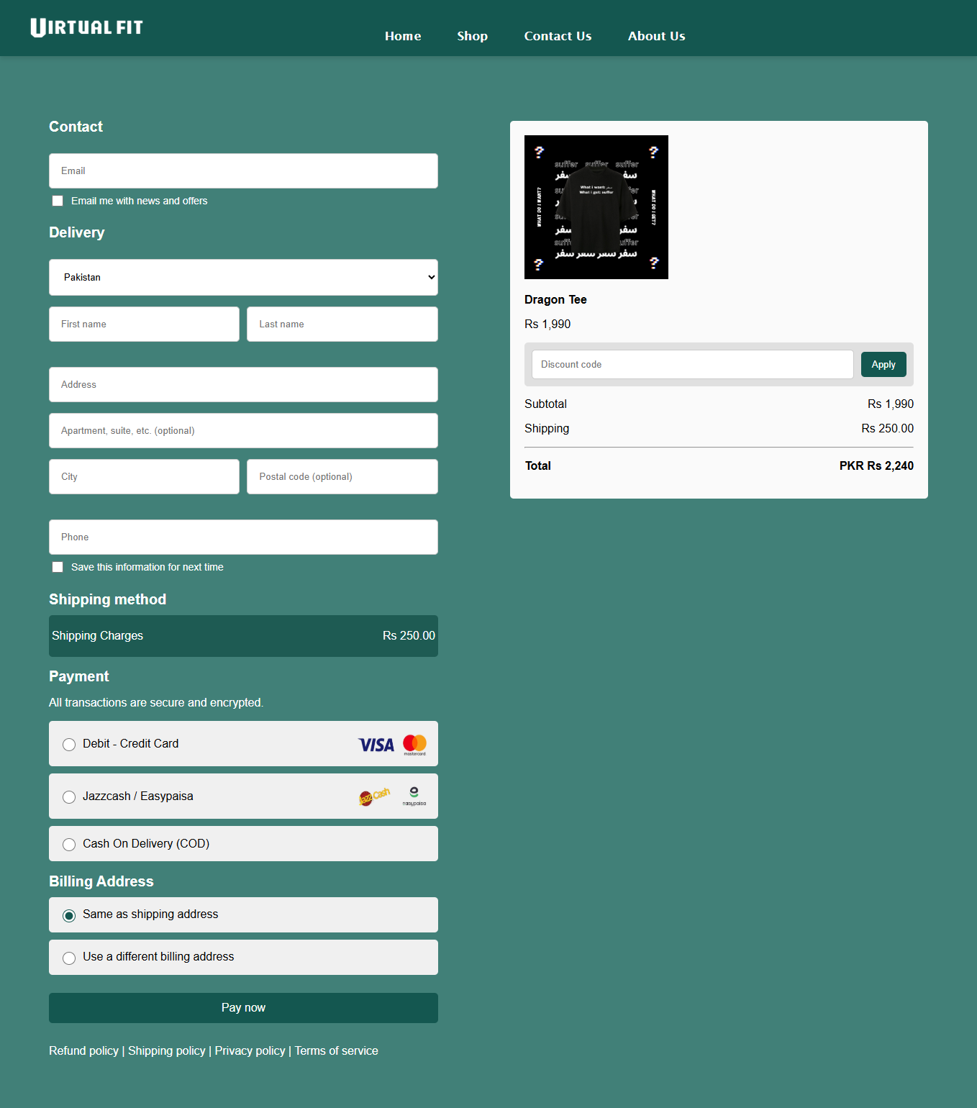

Figure 5.3.3.13 Checkout

# SYSTEM TESTING

## Manual Testing

### System Testing

**Scenario 1: Signup/Login Credentials Syntax**

**Test Steps:**

* Open the website and input details.
* Leave the name, email address and password fields as empty.
* Click next button.

**Expected Result:**

* The website will prompt the user to input valid credentials in the correct syntax via a popup message indicating the required field(s) are empty.

**Scenario 2: User Body Measurements Syntax**

**Test Steps:**

* Visit the website signup page.
* Leave the body measurement fields empty.
* Add Negative values from the slider for body measurements.

**Expected Result:**

* The website will not let the user proceed if the input field(s) are empty.
* The website will not allow the user to input a negative value for body measurement.

**Scenario 3: Navbar Navigation Functionality**

**Test Steps:**

* Open the website and log in.
* Click on the navigation bar options like Home, Shop, Contact us, and About.
* Observe if the correct pages open.

**Expected Result:**

* Each navigation option leads to the appropriate page.
* No errors occur while switching pages, and navigation remains smooth.

**Scenario 4: Fast Website Loading and Image Display**

**Test Steps:**

* Open the website on a stable internet connection.
* Observe the time it takes for the website to fully load.
* Check how quickly images appear on the Home and other pages.

**Expected Result:**

* The website loads quickly, within a few seconds.
* Images are displayed immediately without noticeable delays.

**Scenario 5: Loading of 3D Model**

**Test Steps:**

* Log in to the website and go to the Virtual Try-On section.
* Observe the time taken to load the 3D model.
* Interact with the model by rotating and zooming to test responsiveness.

**Expected Result:**

* The 3D model loads within a short period.
* The model reacts smoothly to user actions like rotation and zooming.

**Scenario 6: Handling Errors When 3D Model Fails to Load**

**Test Steps:**

* Simulate an issue by disconnecting from the internet or using an invalid model link.
* Open the Try-On Room page on the website.
* Observe how the system responds to the failed model load.

**Expected Result:**

* A clear error message appears in the debug console, informing the user about the loading issue.

### Unit Testing

**Test case 1:**

Table 6.1.2.1 Test Case 1

|  |
| --- |
| **Test Scenario:** Checking that an alert is shown when the signup button is clicked with empty fields. |

|  |  |
| --- | --- |
| **Test Case ID:**  TC_01 | **Test Case Description:**  Verify that the system prompts the user to fill out required fields when left empty. |
| **Tester’s Name:**  Arham | **Module Name:**  Sign Up |
| **Prerequisites:**  Stable internet connection | **Environment information:**  Browser: Mercury (Firefox fork)  System: 64 bit Windows 10 |

|  |  |  |  |  |  |  |
| --- | --- | --- | --- | --- | --- | --- |
| **Sr No** | **Test Case Description** | **Test Data** | **Test details** | **Expected result** | **Actual result** | **Status** |
| T-01 | Empty fields check | Leave username, email, and password empty | Leave username, email, and password empty | System should display "Please fill out this field." popup | The popup appears correctly | Pass |

**Test case 2:**

Table 6.1.2.2 Test Case 2

|  |
| --- |
| **Test Scenario:** Ensuring the email field only accepts valid email format. |

|  |  |
| --- | --- |
| **Test Case ID:**  TC_02 | **Test Case Description:**  Validate that incorrect email formats are not accepted. |
| **Tester’s Name:**  Arham | **Module Name:**  Sign Up |
| **Prerequisites:**  Stable internet connection | **Environment information:**  Browser: Mercury (Firefox fork)  System: 64 bit Windows 10 |

|  |  |  |  |  |  |  |
| --- | --- | --- | --- | --- | --- | --- |
| **Sr No** | **Test Case Description** | **Test Data** | **Test details** | **Expected result** | **Actual result** | **Status** |
| T-02 | Email format validation | Enter "testuser123" (without @ and domain) | Click "Sign Up" with invalid email format | System should show popup: "Please enter a valid email address." | The popup appears correctly | Pass |

**Test case 3:**

Table 6.1.2.3 Test Case 3

|  |
| --- |
| **Test Scenario:** Validating that height, waist, and chest sizes cannot be negative values. |

|  |  |
| --- | --- |
| **Test Case ID:**  TC_03 | **Test Case Description:**  Ensure size sliders do not allow negative values. |
| **Tester’s Name:**  Arham | **Module Name:**  Size Input |
| **Prerequisites:**  Size input sliders functional | **Environment information:**  Browser: Mercury (Firefox fork)  System: 64 bit Windows 10 |

|  |  |  |  |  |  |  |
| --- | --- | --- | --- | --- | --- | --- |
| **Sr No** | **Test Case Description** | **Test Data** | **Test details** | **Expected result** | **Actual result** | **Status** |
| T-03 | Negative value restriction | Attempt to input  -1 in size slider | Try setting slider value to negative | Slider should restrict to minimum positive value | Slider restricts correctly | Pass |

**Test case 4:**

Table 6.1.2.4 Test Case 4

|  |
| --- |
| **Test Scenario:** Checking that the "Try-now" button redirects to the virtual try-on page. |

|  |  |
| --- | --- |
| **Test Case ID:**  TC_04 | **Test Case Description:**  Ensure "Try-now" button leads to the correct 3D page. |
| **Tester’s Name:**  Arham | **Module Name:**  Navigation |
| **Prerequisites:**  Try-on page is live | **Environment information:**  Browser: Mercury (Firefox fork)  System: 64 bit Windows 10 |

|  |  |  |  |  |  |  |
| --- | --- | --- | --- | --- | --- | --- |
| **Sr No** | **Test Case Description** | **Test Data** | **Test details** | **Expected result** | **Actual result** | **Status** |
| T-04 | Try-now navigation | Click "Try-now" button | Action: User clicks "Try-now" | User should be redirected to 3D virtual try-on page | Redirection works successfully | Pass |

**Test case 5:**

Table 6.1.2.5 Test Case 5

|  |
| --- |
| **Test Scenario:** Verifying that the navigation bar links direct to the correct pages. |

|  |  |
| --- | --- |
| **Test Case ID:**  TC_05 | **Test Case Description:**  Check navigation bar functionality for correct redirections. |
| **Tester’s Name:**  Arham | **Module Name:**  Navigation |
| **Prerequisites:**  All webpages are active | **Environment information:**  Browser: Mercury (Firefox fork)  System: 64 bit Windows 10 |

|  |  |  |  |  |  |  |
| --- | --- | --- | --- | --- | --- | --- |
| **Sr No** | **Test Case Description** | **Test Data** | **Test details** | **Expected result** | **Actual result** | **Status** |
| T-05 | Navbar functionality | Click "Pants" section | User clicks on "Pants" nav link | User should be redirected to Pants page | Redirection works successfully | Pass |

**Test case 6:**

Table 6.1.2.6 Test Case 6

|  |
| --- |
| **Test Scenario:** Confirming that clicking "Add to Cart" adds the product. |

|  |  |
| --- | --- |
| **Test Case ID:**  TC_06 | **Test Case Description:**  Ensure product is added to cart upon clicking "Add to Cart". |
| **Tester’s Name:**  Arham | **Module Name:**  Cart |
| **Prerequisites:**  Product page is functional | **Environment information:**  Browser: Mercury (Firefox fork)  System: 64 bit Windows 10 |

|  |  |  |  |  |  |  |
| --- | --- | --- | --- | --- | --- | --- |
| **Sr No** | **Test Case Description** | **Test Data** | **Test details** | **Expected result** | **Actual result** | **Status** |
| T-06 | Add to cart | Select a product and click "Add to Cart" | User clicks add button | Product should appear in cart | Product added successfully | Pass |

**Test case 7:**

Table 6.1.2.7 Test Case 7

|  |
| --- |
| **Test Scenario:** Checking if price updates according to quantity in the cart. |

|  |  |
| --- | --- |
| **Test Case ID:**  TC_07 | **Test Case Description:**  Validate that the total price updates when quantity changes. |
| **Tester’s Name:**  Arham | **Module Name:**  Cart |
| **Prerequisites:**  Product added to cart | **Environment information:**  Browser: Mercury (Firefox fork)  System: 64 bit Windows 10 |

|  |  |  |  |  |  |  |
| --- | --- | --- | --- | --- | --- | --- |
| **Sr No** | **Test Case Description** | **Test Data** | **Test details** | **Expected result** | **Actual result** | **Status** |
| T-07 | Price update | Change quantity from 1 to 3 | Update product quantity in cart | Price updates correctly (Unit price × quantity) | Price updated successfully | Pass |

**Test case 8:**

Table 6.1.2.8 Test Case 8

|  |
| --- |
| **Test Scenario:** Checking if clicking on a product loads details dynamically. |

|  |  |
| --- | --- |
| **Test Case ID:**  TC_08 | **Test Case Description:**  Verify that product details and image load on click. |
| **Tester’s Name:**  Arham | **Module Name:**  Product Display |
| **Prerequisites:**  Product Page Template Working | **Environment information:**  Browser: Mercury (Firefox fork)  System: 64 bit Windows 10 |

|  |  |  |  |  |  |  |
| --- | --- | --- | --- | --- | --- | --- |
| **Sr No** | **Test Case Description** | **Test Data** | **Test details** | **Expected result** | **Actual result** | **Status** |
| T-08 | Dynamic product load | Click on a product | Action: User clicks product view button | Product details and image should display dynamically | Product loads successfully | Pass |

**Test case 9:**

Table 6.1.2.9 Test Case 9

|  |
| --- |
| **Test Scenario:** Verifying that the checkout button redirects properly and accepts discount codes. |

|  |  |
| --- | --- |
| **Test Case ID:**  TC_09 | **Test Case Description:**  Ensure checkout page is accessible and discount code field functions. |
| **Tester’s Name:**  Arham | **Module Name:**  Checkout |
| **Prerequisites:**  Cart with products | **Environment information:**  Browser: Mercury (Firefox fork)  System: 64 bit Windows 10 |

|  |  |  |  |  |  |  |
| --- | --- | --- | --- | --- | --- | --- |
| **Sr No** | **Test Case Description** | **Test Data** | **Test details** | **Expected result** | **Actual result** | **Status** |
| T-09 | Checkout navigation and discount code | Click checkout, enter valid discount code "hassan22" | Proceed to checkout | User is redirected, and discount applied correctly | Checkout works and discount applied | Pass |

References

[1] Y. Hwangbo, I. Kim, and M. Kwon, "Effects of 3D Virtual 'Try-On' on Online Sales and Customers' Purchasing Experiences," *Journal of Business Research*, vol. 13, no. 2, pp. 123-135, 2020.

[2] D. Song et al., "Image-Based Virtual Try-On: A Survey," *arXiv preprint arXiv:2311.04811*, 2023. Available: https://arxiv.org/abs/2311.04811.

[3] M. Javornik, "The Impact of Augmented Reality on Consumer Purchase Intentions in E-Commerce," in *Augmented Reality in Retail and Consumer Marketing*, 1st ed., Springer, 2019, pp. 75-98.

[4] "Virtual Try-On for E-commerce: A Complete Guide," Zakeke. Available: https://www.zakeke.com/pillars/virtual-try-on-for-ecommerce-a-complete-guide/. [Accessed: Jan. 27, 2025].